ALTINURE NEWSLETTER
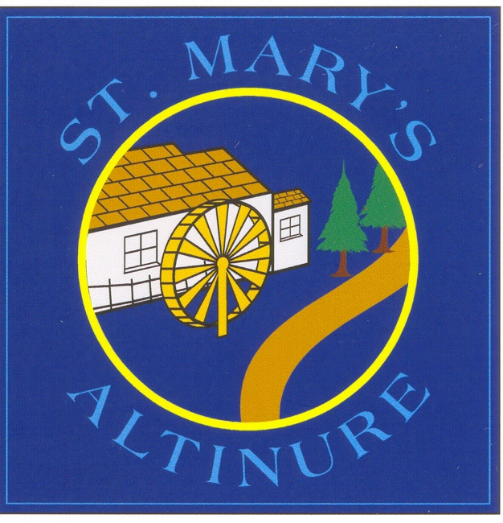
ISSUE 3 – JANUARY/FEBRUARY 2024
SPORTS AND IN/AFTER SCHOOL ACTIVITIES
Monday
Yoga with Monica Donaghy –
P4 – 3-4pm – 5 sessions
(15th Jan – 19th February)
P3 Yoga will begin on 26th February for 5 sessions until 8th April 3-4pm
Tuesday
Swimming Yr 7 10.15am – 12.20pm
(Last swimming session is 23rd Jan)
Literacy and Numeracy Club – P5 – 4 sessions – (Tues 16th Jan – Tues 6th Feb)
Wednesday
Derry GAA Coach Eimear McNicholl – all classes
Thursday
EA Violin – Mrs Small – KS2 - 1- 3pm
Irish – P5-7 1-3pm
Gymnastics – P1 2-3pm & P6 -3-4pm - 5 weeks –
(Thurs 11th Jan – 22nd Feb)
___________________________________________
TIN WHISTLE
Mrs Boyle will teach tin whistle to Primary 6 and 7 pupils on Wednesday afternoons, beginning for Primary 6 on Wednesday 24th Jan. At the same time, Mrs McAleer will teach Film Literacy to Primary 4. Tin whistles will be on sale at reception at a cost of £5.00 each.
_______________________________________________
CATHOLIC SCHOOLS WEEK (beginning Jan 22nd)
The theme of Catholic Schools Week is ‘Communities of Service.’ To launch Catholic Schools Week, Bishop McKeown will celebrate Mass at 10am on Tuesday 16th January in Saint Eugene’s Cathedral. Mrs Redmond and four Primary 5 pupils will attend this special Mass and it can be viewed via the cathedral webcam at:
http://www.steugenescathedral.com/webcam.html
GRANDPARENTS DAY
As part of Catholic Schools Week, we are having a Grandparents Day celebration. Grandparents are invited into school at 10.30am on Wed 24th January so that pupils can show their appreciation for all that grandparents do. Refreshments will be provided. We look forward to seeing you there!

FRIENDS OF ST. MARY’S PS BINGO FUNDRAISER
Many thanks to everyone who attended or helped to organise our successful Bingo event in November. We particularly thank our PTA committee, Banagher GAA and all those members of the community who generously sponsored our prizes or donated to our draw. The final total raised was £2517.70 which will help to pay for new classroom laptops. We are extremely grateful!
P5 ASSEMBLY
Primary 5 assembly will take place on Friday 9th February at 9.30am. All welcome.

CHARITY DONATIONS
Two hampers were presented to St. Vincent de Paul before Christmas and these brought joy at Christmas to families in need. Thank you to everyone who supported our hamper draw.
Many thanks also to all parents who donated to Trocaire in lieu of giving staff gifts at Christmas. £100 was raised and will be presented shortly. Again, thank you for your continued support!

SCHOOL CLOSURES
Term 2
Teachers/Ancillary Staff Strike – closed to pupils –
Thursday 18th Jan
More information to follow

Mid Term – Mon 12th Feb – Fri 16th Feb 2024
St Patrick’s Day Mon 18th March 2024
Easter – Wed 27th March – half day (12 noon)
Closed Thurs 28th March – Fri 5th April 2024
Return to school Mon 8th April 2024
Term 3
May Bank Holidays – Mon 6th May 2024, Mon 27th and Tues 28th May 2024
School Closes – Half day Fri 28th June 2024
__________________________________________________
TEACHING PRACTICE STUDENT
We are looking forward to having Miss Erin McReynolds begin her teaching practice placement in P4 on Monday 5th February. Miss McReynolds will be with us until Friday 22nd March. We hope she enjoys her time in our school!
P7 TOUR OF THE CATHEDRALS
Charlotte has organised a trip for all Primary 7 classes in the parish on Wednesday 7th February. Pupils will experience a tour of St. Eugene’s Cathedral and the Longtower Cathedral and will learn about the history of both. It should be a fun and educational trip. Pupils should bring a packed lunch to school that day.
CUMANN NA mBUNSCOIL QUIZ
A P7 team will compete in the Cumann Na mBunscoil quiz at 10am on Wednesday 28th February in Owenbeg. We wish them luck!
_____________________________________________
P1 PARENT MEETINGS
Parent Teacher meetings for Primary One pupils will take place from Monday 29th January to Thursday 1st February between 2.30 and 3.45pm. Appointments will be issued shortly.

SPORTS
TRANSFER 2024
Transfer results will be available to pupils and their parents from 8am on Saturday 27th January 2024. Parents can access these results in ‘Statement of Outcomes’ when logged into the SEAG website. Good luck to all pupils who sat the test!
Post Primary School applications must be made online by Year 7 parents. The online portal will open at 12 noon on Tuesday 30th January 2024 and will close at 12 noon on Thursday 22nd February 2024.

The Admissions Criteria for Post Primary Schools will be published on the Education Authority website on Thursday 11th January. Parents must consider the Admissions Criteria carefully when making their school choices. Evidence must be provided of the criteria such as receipt of Free School Meals.
It is of utmost importance that parents list at least 3 schools on their child’s Post Primary application and at least one of those choices should be a non-grammar school. An online Information session will be held on Tues 30th January at 3.30pm by Miss Doyle and Mrs Redmond to provide support for parents in understanding post primary schools admissions criteria. More details to follow.

Most post primary schools have Open Days so that P6 and P7 pupils and their parents can visit. Keep an eye on school websites/social media for updated information. We have already posted Open Day information on our website/Facebook page. Schools will also send teachers to talk to the P7 class about what their post-primary school has to offer. __________________________________________
CONFIRMATION
Confirmation will take place in St. Mary’s Church Altinure on Saturday 2nd March 2024 at 11am. Lafayette Photography will be available to take photographs in the church before and after the ceremony. (Families can avail of two pews in the chapel due to the small class size.)
Primary 7 pupils will complete online Confirmation sessions in the week beginning Mon 8th January, organised by the Derry Diocesan Catechetical Centre. P7 pupils will also attend a Confirmation retreat on Tuesday 20th February in Fincairn Hall as part of their preparations.
CHILDREN’S ADORATION
Adoration will take place in school for P4-7 on Monday 15th January from 10 -12 noon. Children should bring their own rosary beads if possible.
FIRST CONFESSIONS
First Confessions for the Year 4 pupils will take place in St Mary’s Church, Altinure on Tuesday 20th February after 10am Mass. All parents welcome. Pupils can wear their own clothes that day.

FIRST COMMUNION
First Communion will take place on Saturday 11th May at 11am in St. Mary’s Church, Altinure. Lafayette Photography will be available to take photographs before and after the ceremony.
The next Do This In Memory Mass for P4 will take place on Sunday 28th January at 10.30am in St. Mary’s Church, Altinure. Well done to all the boys and girls who have participated so wonderfully in these Masses so far this year and thanks to Mrs Boyle for preparing the pupils so thoroughly.

S

SAFER INTERNET DAY
Safer Internet Day will take place on Tuesday 6th February. That day, pupils in all classes will discuss internet safety and strategies they can use to stay safe online. Cyber Pal will also conduct workshops with Year 5, 6 and 7 pupils this term to enhance the older children’s understanding of how to protect themselves on the internet.
VIOLIN TUITION
Fees for EA violin tuition are now due for Term 2/3. If your child undertakes EA violin lessons with Mrs Small, please issue your final payment instalment of £60 to reception as soon as possible. Many thanks.
________________________________________________
YEAR 1 ADMISSIONS
Children born on or between 2 July 2019 and 1 July 2020 (inclusive) are now eligible for a Primary One place in September 2024. Any child born on or between 1 April 2019 and 1 July 2019 (inclusive) and children born before 1 April 2019 but with a due date on or after 1 April 2019 whose parents deferred their admission to primary school in September 2023 are also eligible. Children born on or between 1 April 2020 and 1 July 2020 (inclusive), and children born before 1 April 2020 but whose due date was on or after this date may submit a request to defer P1 admission for September 2024.
Applications will again be digital this year and application forms must be completed on EA Connect at https://connect.eani.org.uk/parent/ The application online portal will open on 9th January at 12 noon and will close on January 26th at 12 noon. Feel free to contact Mrs Redmond on 02877781384 or email on mredmond460@c2kni.net if you need support with your application or to arrange a school visit.
ROAD SAFETY QUIZ
A Road Safety quiz will take place in the Guildhall, Derry on Wednesday 17th January at 10am. A staff member and 4 Primary Seven pupils will attend. We wish them luck!
CUED SPELLING
Primary 5 and 6 pupils will participate in a four week Cued Spelling Programme to improve their spelling accuracy. Primary 6 pupils will teach P5 pupils cues and strategies to help them to remember their spelling words. The programme is usually effective in increasing spelling scores and children enjoy it as well!
SPORTING EVENTS
Blitzes:
Thurs 8th February – Meadowbank, Magherafelt – Girls’ Football and Hurling
Tuesday 27th February – Meadowbank, Magherafelt – Boys’ Football
Cross-Country: Oakgrove College, Derry – Friday 26th January and St. Patrick’s and St. Brigid’s College – Friday 2nd February
EASYFUNDRAISING APP
Thanks to everyone who has already used the easyfundraising app when making online purchases. This app costs you nothing but raises much needed funds for our school. If you haven’t already done so, please do! We appreciate your support!!
_____________________________________________________
LITERACY BOOK FAIR
The Scholastic Book Fair will arrive on Friday 2nd Feb and remain for one week, leaving on Friday 9th February. We are looking forward to it!

