MICROSOFT TEAMS
PARENT USER VISUAL GUIDE

J. Cooke Oct 2020

If you have already downloaded the Teams app to your laptop you can skip to page 4 of this document.
If you need to download the app then start here.
Open either Internet Explorer or Google Chrome.
Search for C2K MySchool login.

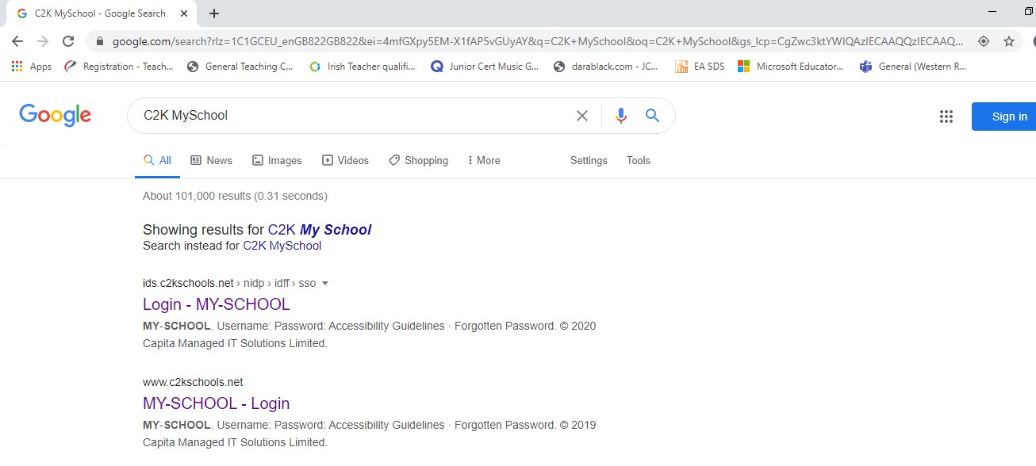

Enter your child’s C2K username and password in the following format:
jsmith123@c2ken.net then click ‘login’.

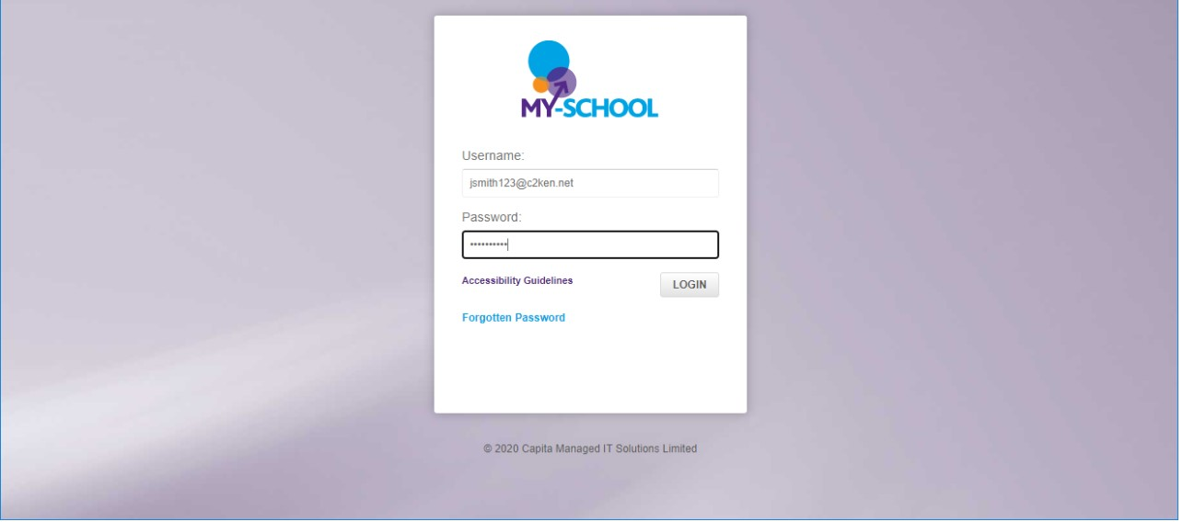

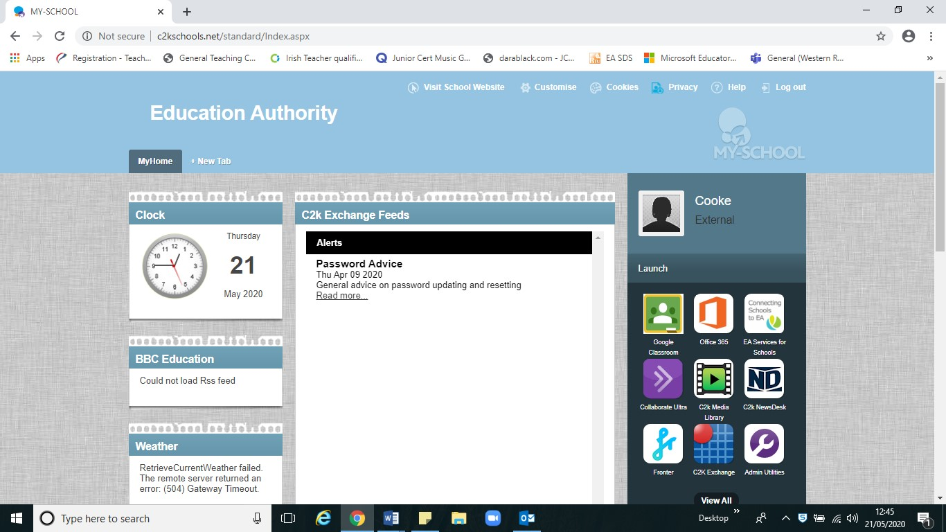
Click on Office 365.

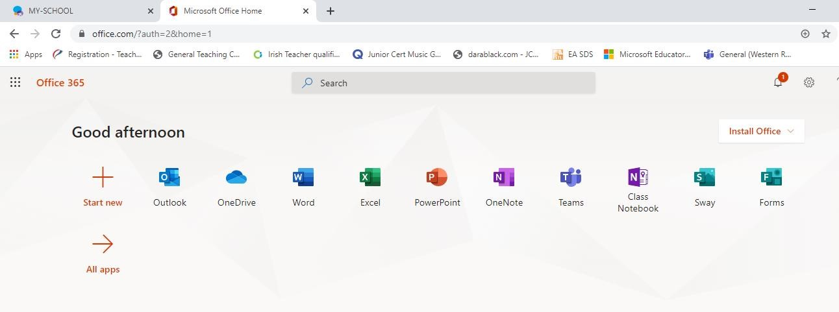
Click on Teams

Click on your initials on the top right of the screen and click on ‘Download the desktop app’. Don’t worry if you can’t get the app to work – you can use Teams on your internet browser from here.
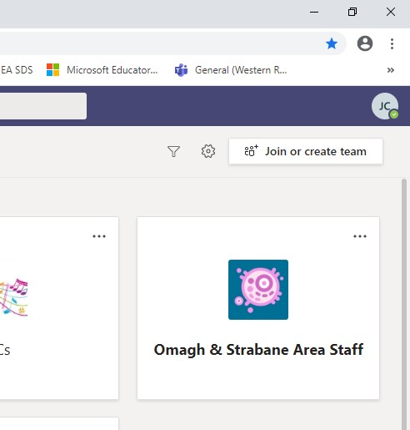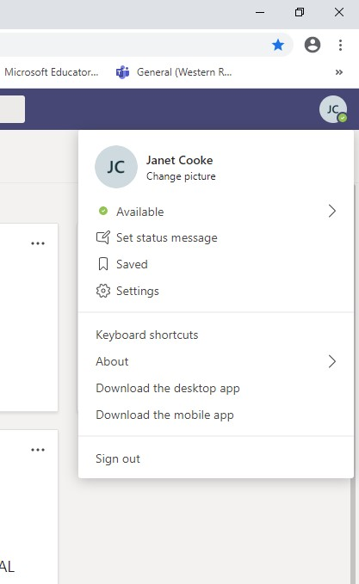

You will see it appear on the bottom left hand of your screen, click on it and the app will open. This will mean it will appear on your desktop so you can login directly to Teams from there from now on.

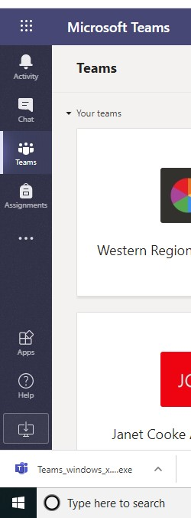

Open your Teams app and log in using your child’s C2K username and password.

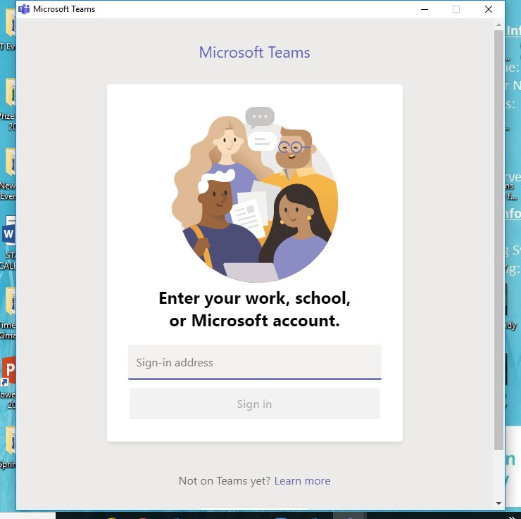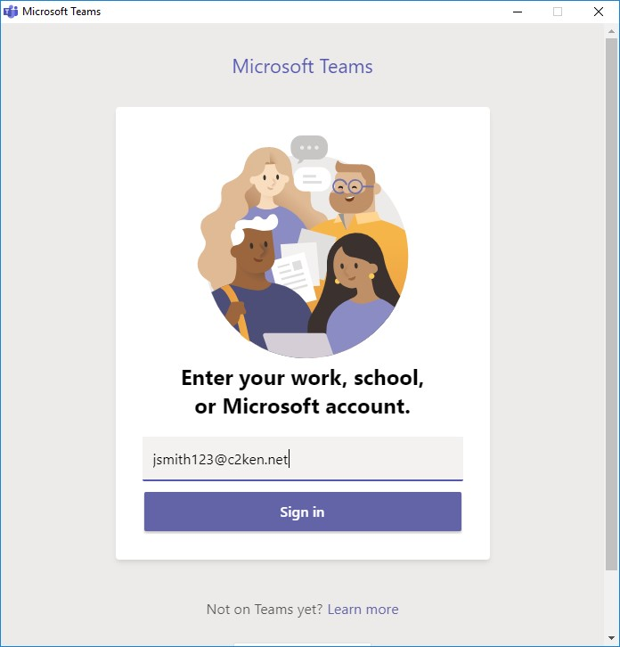

Once your consent form has been submitted your tutor will have placed your child into a relevant Team. This is be on your child’s screen, once they click on it they can access the resources / materials their tutor has uploaded.

