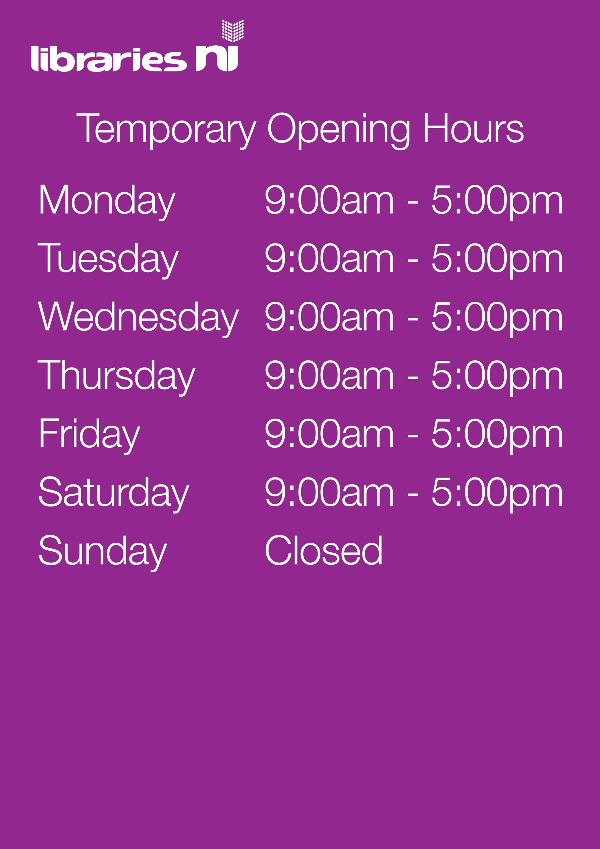

Book and Collect Hours

This new service allows customers to phone their local library to request a selection of books and then arrange a contactless collection. Details of when you can phone your local library to arrange a collection are listed below.

Monday 10:00-1:00 and 2.00-4.00 pm

Tuesday 10:00-1:00 and 2.00-4.00 pm

Wednesday 10:00-1:00 and 2.00-4.00 pm

Thursday CLOSED

Friday 10:00-1:00 pm

Saturday 10:00-1:00 pm

Sunday CLOSED

Telephone: 028 7774 1475

Email: dungiven.library@librariesni.org.uk