**25/06/20**

**Dear Primary Six Parent,**

**ONLINE SUPPORT FOR CHILDREN ENTERING YEAR 7**

The Department of Education (DE) has proposed a scheme whereby all current Year 6 children and their parents may access online learning programmes in English and Maths.

Children will require access to a tablet, laptop or smart phone to access the programmes. **Parental engagement with this scheme is optional.**

There are many online support materials; however, **two** commercial programmes that could be used are IXL Learning and Mathematics Mastery. Both of these programmes contain Numeracy and Literacy.

As with the use of any online programme or application it will be important that parents consider both appropriate levels of screen time and their child’s online safety. Parents may find the EA online safety guidance material useful:

<https://ineqe.com/safeguarding-hub/>

<https://www.saferinternet.org.uk/advice-centre/parents-and-carers>

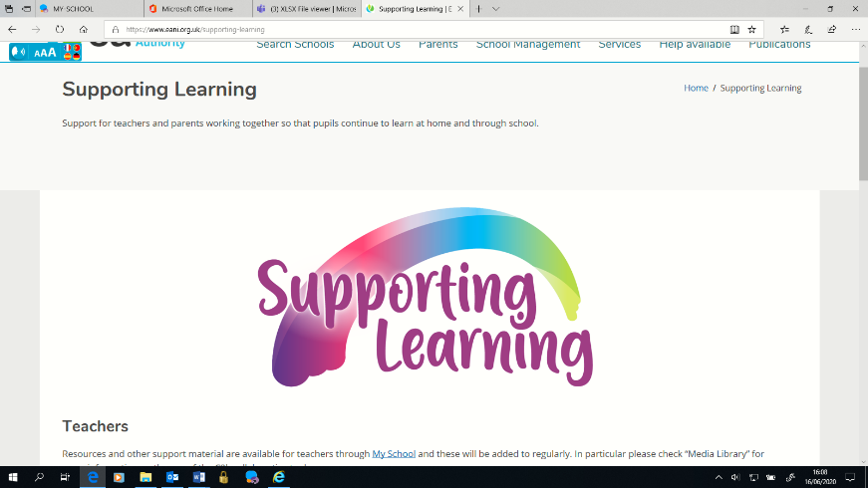In addition, the [‘Supporting Learning’](https://www.eani.org.uk/primary-school-education-resources) material available on the Education Authority (EA) website and specifically EA designed material, link directly with Northern Ireland Curriculum, provide reinforcement and a reminder of the key literacy and numeracy concepts across Key Stage 2.

__________________________________________________________________________________

**IXL LEARNING**:

Parents can either sign in as a guest (this will only provide you with a daily practice limit 6-8 questions before it prompts you to ‘become a member’). Registration requires a valid email address. Otherwise parents would need to register themselves.

A [Parental Guide](https://uk.ixl.com/inspiration/family-guide-uk.pdf) / [Quick Guide](https://uk.ixl.com/userguides/IXLQuickStart_Child.pdf) provides a quick tour of the programme.

The IXL Learning **app** can be downloaded from Google Store/Apple Store and supported by the [IXL Mobile App Guide](https://uk.ixl.com/resources/IXL_Mobile_Apps_Sign-in_Guide.pdf)

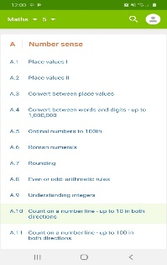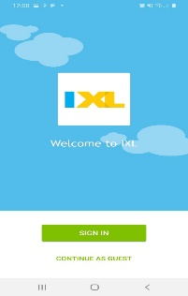

Through both platforms parents can select:

* The **numeracy** or **literacy** option,
* The corresponding class/age/stage for their child [year 5 level in England is approximately equivalent to year 6 NI] or,
* The ‘search’ option through which a particular numeracy or literacy aspect on which to focus may be identified, for example – adding 9 or, proper nouns.

If you click on **learning** then **National Curriculum** then **Northern Ireland** the content will be mapped to the **Northern Ireland Curriculum** by key stage.

___________________________________________________________________________

**MATHEMATICS MASTERY:**

**Mathematics Mastery** provides a structured programme for **literacy** and **numeracy** and step by step guides for parents.

Parental access to the programme is straight forward, there is no need to register just access the **‘Free Covid-19 Resources’** at the top of the **Mathematics Mastery** homepage:

<https://www.mathematicsmastery.org/>

There are two maths packs for each year group, one has the guidance pages and the other the pupil facing resources. Parents need to access both packs as the pupils’ packs do not make sense without the guidance. To reduce printing, the guidance packs can be accessed digitally as they contain embedded video links.

There are also two literacy packs with the guidance included.

**Year 5** [approximately equivalent to year 6 in NI] **printable packs**

* [Maths Year 5 Weeks 1-4 Guidance pack](https://www.mathematicsmastery.org/wp-content/uploads/2020/03/Parent_Maths_Y5_W1-4.pdf)(easy for parents/guardians to guide learning)
* [Maths Year 5 Weeks 1-4 Pupil pack](https://www.mathematicsmastery.org/wp-content/uploads/2020/03/Student_Maths_Y5_W1-4.pdf)
* [Maths Year 5 Weeks 5-9 Guidance pack](https://www.mathematicsmastery.org/wp-content/uploads/2020/03/Parent_Maths_Y5_W5-9.pdf)(easy for parents/guardians to guide learning)
* [Maths Year 5 Week 5-9 Pupil pack](https://www.mathematicsmastery.org/wp-content/uploads/2020/03/Learner_Maths_Y5_W5-9.pdf)
* [English Year 5 Workbook (week 1-4)](https://www.englishmastery.org/wp-content/uploads/2020/03/Pupil_English_Year-5-Workbook-WK1-4-V2.pdf) (guidance included)
* [English Year 5 Workbook (week 5-9)](https://www.englishmastery.org/wp-content/uploads/2020/03/Pupil_English_Year-5-Workbook-WK5-8-V2.pdf) (guidance included)

We wish to stress that, although both these programmes are useful and free to access, this government scheme is purely optional and there is no expectation for pupils to participate. **This is solely a parental choice.**

Feel free to look at these resources and make up your own mind. Certainly, I feel that the pupils and parents need a little bit of a break at some point!

Have a safe and restful summer.

Yours sincerely,

Mrs Mary Redmond

Principal