ALTINURE NEWSLETTER
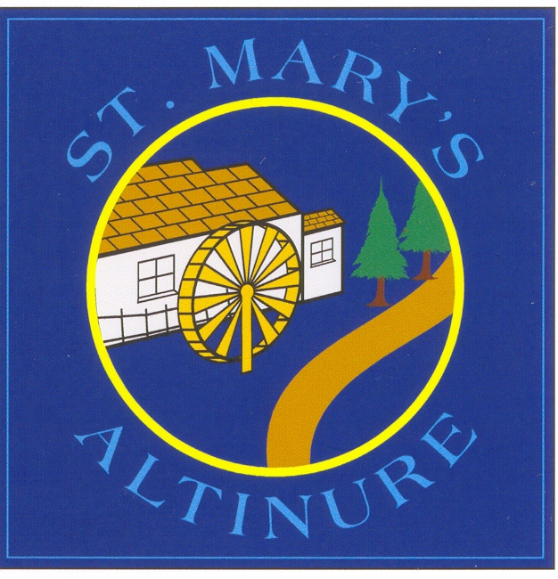
ISSUE 5 – MAY/JUNE 2024

DURING/AFTER SCHOOL ACTIVITIES
Monday – Yoga- P5- 3-4pm (last session Mon 3rd June) Please note that for one week only, yoga will take place on Tuesday 21st May instead of Monday 20th May.
Tuesday – O McGill – Literacy Service
Wednesday- Altinure Choir practice with Aine Patton – 3-4pm
Derry GAA Gaelic coaching with Eimear - all classes (final session 22nd May)
Thursday – Irish with Mairtin – P5, 6 & 7
____________________________________________
SACRAMENTS
P4 children will make their First Communion at 11am on Saturday 11th May in St. Mary’s Church, Altinure. Each family will have access to two rows of seats. Please be in your seat by 10.45am.
Lafayette Photography will be in the chapel to take a group and a family photo. Please let school know if you do not want a photograph taken.
After the ceremony, Fr McGavigan will kindly provide an ice-cream van and the PTA will also provide tea/coffee and a sweet treat for families. Thank you to the many Primary Three parents who have offered their help with refreshments. Eimear McCloskey, our PTA Chairperson, will be in touch if she needs your support.
Thank you to Mrs Boyle for preparing the First Communicants so thoroughly. We hope you all have a lovely day!

___________________________________________
P7 SCHOOL PLACEMENTS
P7 pupils and their parents will be informed by email of their school placements on Saturday 18th May. If your child is unplaced, you will need to act quickly and select a place in a school which still has places available. Telephone the Admissions Helpdesk on 028 9598 5595 for support. Good luck to everyone!
____________________________________________
PUBERTY TALK
A Puberty talk will take place for P7 pupils on Wednesday 19th June at 2.15pm. Boys and girls will attend in separate groups. They will watch an informative video followed by discussion with Miss Doyle (girls) and Mrs Redmond (boys). Attendance is optional and parents must provide consent for pupils to participate. More information to follow.
CYCLING PROFICIENCY TRAINING
Year 7 pupils have been working hard on their Cycling Proficiency training with Miss Doyle and it is going really well. Thanks to Miss Doyle for providing this instruction to P7.
___________________________________________P6 TO VISIT PARK LUNCHEON CLUB
P6 are looking forward to joining Magdalena and the members of Park Luncheon Lunch for a singing session on Thursday 2nd May. Pupils will have lunch here, then walk to the Resource Centre for 1.15pm.

_________________________________________

SCHOOL CLOSURES
Bank Holiday – Mon 6th May
Bank Holiday Mon 27th & Tues 28th May
(Staff Development days)
Half day: Friday 28th June (summer holidays)
YEAR ONE INDUCTION PROGRAMME
Mrs McKenna will visit Park Community Playgroup at 11.30am on Friday 10th May to meet our new pupils. On Friday 31st May, our new pupils are invited to school at 9.30am for a Games Day where they will play and have fun while getting to know the new surroundings.
Parents are invited to attend our school assembly hall for an information session on school life on Thursday 6th June at 7pm. This session will also provide opportunities for parents to become informed of school policies and practices.
Parents and their children are then invited to a walk-through induction session on Friday 21st June. Times will be staggered. At this session, starting dates and Smart Packs will be given out. More information will follow. We appreciate your continued support for all our initiatives.

____________________________________________
YEAR 6 TRANSFER MEETING
The Schools Entrance Assessment Group (SEAG) are now responsible for the post primary school transfer test. The test will take place over 2 Saturdays in November (16th Nov & 23rd Nov 2024) and it will be used by all post-primary schools that use academic selection. There is a cost of £20 to register your child for these tests, although parents of children receiving Free School Meals are exempt from this cost. It is parental responsibility to complete the application process. To register your child, you must first register yourself as a parent/guardian on the SEAG website at www.seagni.co.uk You then must complete the online registration process for your child. Registration will open at 8am on Monday 20th May 2024 and close at 11.59pm on Friday 20th September 2024. Visit seagni.co.uk/guidance-for-parents or visit the grammar school websites for more information. To help you understand changes in the transfer process, a transfer information meeting will take place online via Google Classroom on Wednesday 8th May at 3.30pm for parents of current P6 pupils. Mrs McAleer and Mrs Redmond will facilitate the meeting. You can enter the meeting via your child’s Google Classroom account and we will also text a link before the meeting. More details to follow.
PANTS WEEK (6th-10th May)
Next week, pupils will participate in the NSPCC PANTs Week where they will learn more about how to keep themselves safe. We will share the NSPCC PANTs rules online and we encourage you to discuss these with your children.

FAN THE FLAME MASS
Year 7 pupils will attend the Fan the Flame Mass in Celtic Park, Derry on Thursday 6th June. It is always a wonderful experience – look out for photos on the Derry Diocesan website!
_________________________________________________
SCHOOL TRIPS
P7 pupils are really looking forward to their school trip to Emerald Park on Monday 10th June. A letter will follow soon with more details. As they will be exhausted, they are allowed to stay off school on Tuesday 11th June. This will not impact negatively on their attendance. (They can still attend if that suits families better). Hopefully they will have a wonderful time!
All other classes will have trips as follows:
P1/2- Jet Centre- Thursday 30th May
P2/3- The Play Shed, Derry – Wednesday 29th May
P4 – Brunswick Movie Bowl- Wednesday 19th June
P5- Brunswick Movie Bowl – Tuesday 11th June
P6- Brunswick Movie Bowl- Wednesday 12th June

Buses are proving very expensive this year. In an attempt to reduce the cost for parents, we will subsidise the meal for each child using fundraising proceeds from our Split the Pot draw, alongside funding received from Rapid NI. Letters will follow when buses have been confirmed and specific costs have been finalised.
_________________________________________________
SPORTING EVENTS
Fr Gallagher Blitz- Faughanvale PS - Friday 10th May
North Derry Girls Football Blitz – Glenullin- Mon 13th May
North Derry Boys Football Championship – Glenullin – Thursday 23rd May
Good luck to all our players!
_________________________________________________
ADORATION PROCESSION
At 10am on Monday 13th May, instead of indoor Adoration, all pupils will walk in procession behind a statue of Our lady whilst reciting this rosary. This is to venerate Our Lady in the month of May and it will be a very special event on the Feast of Our Lady of Fatima. The first two decades of the rosary will be said by all classes in the school grounds. Then P4, 5, 6 & 7 will walk to St Mary’s Altinure Church to say the remaining three decades. All classes will also have May Altars and we encourage parents to create May Altars also at home as a focus for prayer. We thank Laura and her Adoration team for their continued support.
_________________________________________________
P7 ASSEMBLY
P7 assembly will take place on Friday 7th June at 9.30am and family members are welcome. This will be the showcase event for their Junior Entrepreneur Project. We are so proud of their dedication and hard work over the last few months and their resultant wax melt business has been a huge success. Proceeds from their project will subsidise the Primary 7 school trip. Well done to the staff and pupils in Primary 7!
GEORGE MURPHY SINGER/STORYTELLER
On Friday 24th May, George Murphy will join us for a morning of storytelling and song. P1-4 pupils will enjoy a session from 9.30-10.30am and P5-7 will sing along at 11.05am – 12.05pm. It should be fun!
SHARED EDUCATION VISITS
All classes in our school will meet our Cumber Claudy friends this month to play and have fun. P1/2 and P7 have already met and had a great time together. P4 and P5 will meet on Thursday 2nd May and P2/3 and P6 will meet on Thursday 9th May. We hope the sun shines so they can enjoy the outdoors together!

_________________________________________________

_______________________________________________
TASTER DAY
P6 will visit St. Patrick’s and St. Brigid’s College for a ‘Taster Day’ on Tuesday 11th June. They will participate in practical activities and find out what school life is like there. It always proves to be an enjoyable day for all involved.
_________________________________________________
LEAVERS’ MASS
P7 pupils will have their official last day of school on Monday 24th June. On Friday 21st June, pupils will have celebrations in class with Miss Doyle. On Monday 24th June, attendance at school in the morning is optional for P7s. All P7 pupils and parents are then invited to attend the Leavers’ Mass that afternoon at 1.30pm in the school assembly hall. Fr McGavigan will be the celebrant. Pupils should wear their own clothes. Records of Achievement will be presented and there will be refreshments. We wish our Primary 7 leavers the best of luck for their new post-primary schools!

SPORTS DAY
Sports Day will take place on Friday 14th June this year. Parents are welcome to attend and the first race should take place at approximately 9.50am. Please remember to keep the playground gates closed at all times to ensure pupil safety.
Pupils will need to wear sportswear and sun cream if it is sunny. There will be no tuck shop but pupils can buy a bagged selection of sweets for £1.00 through school reception. Pupils can also bring in sweet treats from home (no fizzy drinks or nuts allowed). Refreshments will be available for parents on the day as well – more details to follow.
Remember you only have permission to photograph your own child and cannot post photographs of other children on social media without permission from their parents!
We are really looking forward to the whole day!

LIFESAVING SKILLS IN P7
P7 pupils will participate in a CPR Awareness workshop soon. They are looking forward to it!
CONGRATULATIONS TO CHARLOTTE
Congratulations to Charlotte, our Faith Formation Co-ordinator, and her husband Conor on the birth of their beautiful baby girl, Millie. We hope that both Mum and baby are doing well and we send them our best wishes!
CAKE SALE FUNDRAISER FOR HOPE CAMP
On Tuesday 21st May at 10.30am, we will have a Cake Sale in our assembly hall to raise money for HOPE. (Funds raised will be split between Banagher and Claudy HOPE Summer Camps.) We would be delighted if parents would support the Cake Sale by sending in at least one food item per child – cakes, scones, buns, biscuits and sweet treats will all be welcomed. Please remember that no nuts are permitted. Baked products should be dropped off at reception or sent in with your child on Monday 20th May. Parents and members of the community are then welcome to come to school at 10.30am on Tuesday to purchase the produce on sale. You are also welcome to stay for a cup of tea and a chat. Thank you for your continued support and we look forward to seeing you there!
P3 & P7 LITERACY BUDDIES
P7 pupils will pair up with P3 pupils on Monday afternoons to play Literacy games. This will boost the Literacy skills of P3 pupils while encouraging independence and confidence in P7. This project will begin on Monday 13th May.

