Contact Details

St Mary’s Primary School Catholic Maintained
Altinure Co. Educational
70 Monadore Road,
Park Age Range 4 - 11
Claudy
Co Derry
BT47 4DP

Tel 028777 81384 info@stmarysps.park.ni.sch.uk

Chairman of Governors Mr Eddie Kerlin
Principal Mrs. Mary Redmond
Number on Rolls 1st September 2017 - 161
Admissions Number 29
Enrolment Number 200

THE BOARD OF GOVERNORS

Nominated by the Transferors/Trustees
Rev Fr P Baker
Mrs J Lynch
Mrs M Gormley

Nominated by Western Education & Library Board
Mr E Kerlin
Mr. Michael Forester

Nominated by Department of Education
Mr P McMenamin

Elected by Teaching Staff
Miss Ursula Doyle

Elected by Parents

Mr J Donaghy

Principal (Non Voting)
Mrs Mary Redmond

Front Cover – School Crest – designed by Daryl Mullan P7 School Year 2005

Teaching Staff

Principal Mrs Mary Redmond M.Ed. PQH

Vice Principal Mrs M Jamison B.Ed.

P1Teachers Mrs C McKenna B.Ed./ Mrs. A.M. Hegarty B.A.
(job share)

P2 Teacher Mr. D Cartin, B.Ed./ Miss B McKinney

P3 Teacher Mrs A Boyle B.Ed

P4 Teacher Mrs M Jamison B. Ed./Mrs C. Hawkins-Murphy

P5 Teacher Mrs Redmond/ Mrs C McKenna B. Ed.

P6 Teacher Mrs C McAleer BA. PGCE

P7 Teacher Miss U Doyle, B. Ed.

Ancillary Staff

School Secretary Mrs M Moore

Classroom Assistants Mrs Alice McBride/Mrs Shana O’Neill
Mrs Pauline McElhinney
Mrs Lisa Coll
Mrs Rosemary Moore
Miss Charlene O’Neill
Mrs Michelle O’Neill/Miss Lauren McLaughlin

Cook in Charge Mrs P Feeney
Assistant Cooks Mrs M McElhinney
Mrs T Conway

Caretaker Mr Liam Conway

Supervisory Assistants Mrs M Moore
Mrs Lisa Coll/Miss Charlene O’Kane
Mrs Pauline McElhinney

Meet the Staff

Teaching staff
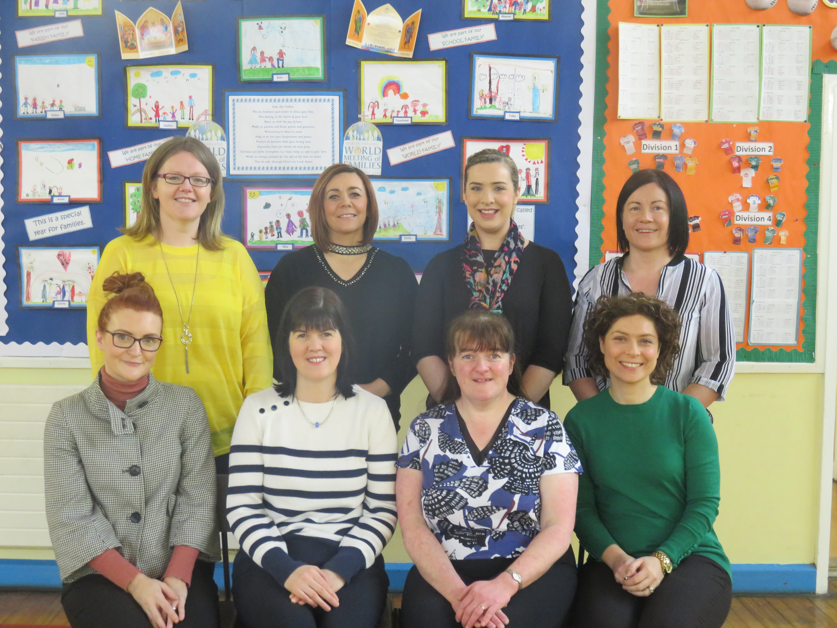

Back left: Mrs Hawkins-Murphy (Yr. 4), Mrs Boyle (Yr. 3), Mrs C McKenna (Yr 1/5), Miss Doyle (Yr. 7) Front left: Miss McKinney (Yr. 2), Mrs Redmond (Principal/Yr 5), Mrs Hegarty (Yr 1), Mrs McAleer (Yr. 6)
Missing from photograph: Mrs Jamison and Mr. Cartin

Ancillary Staff
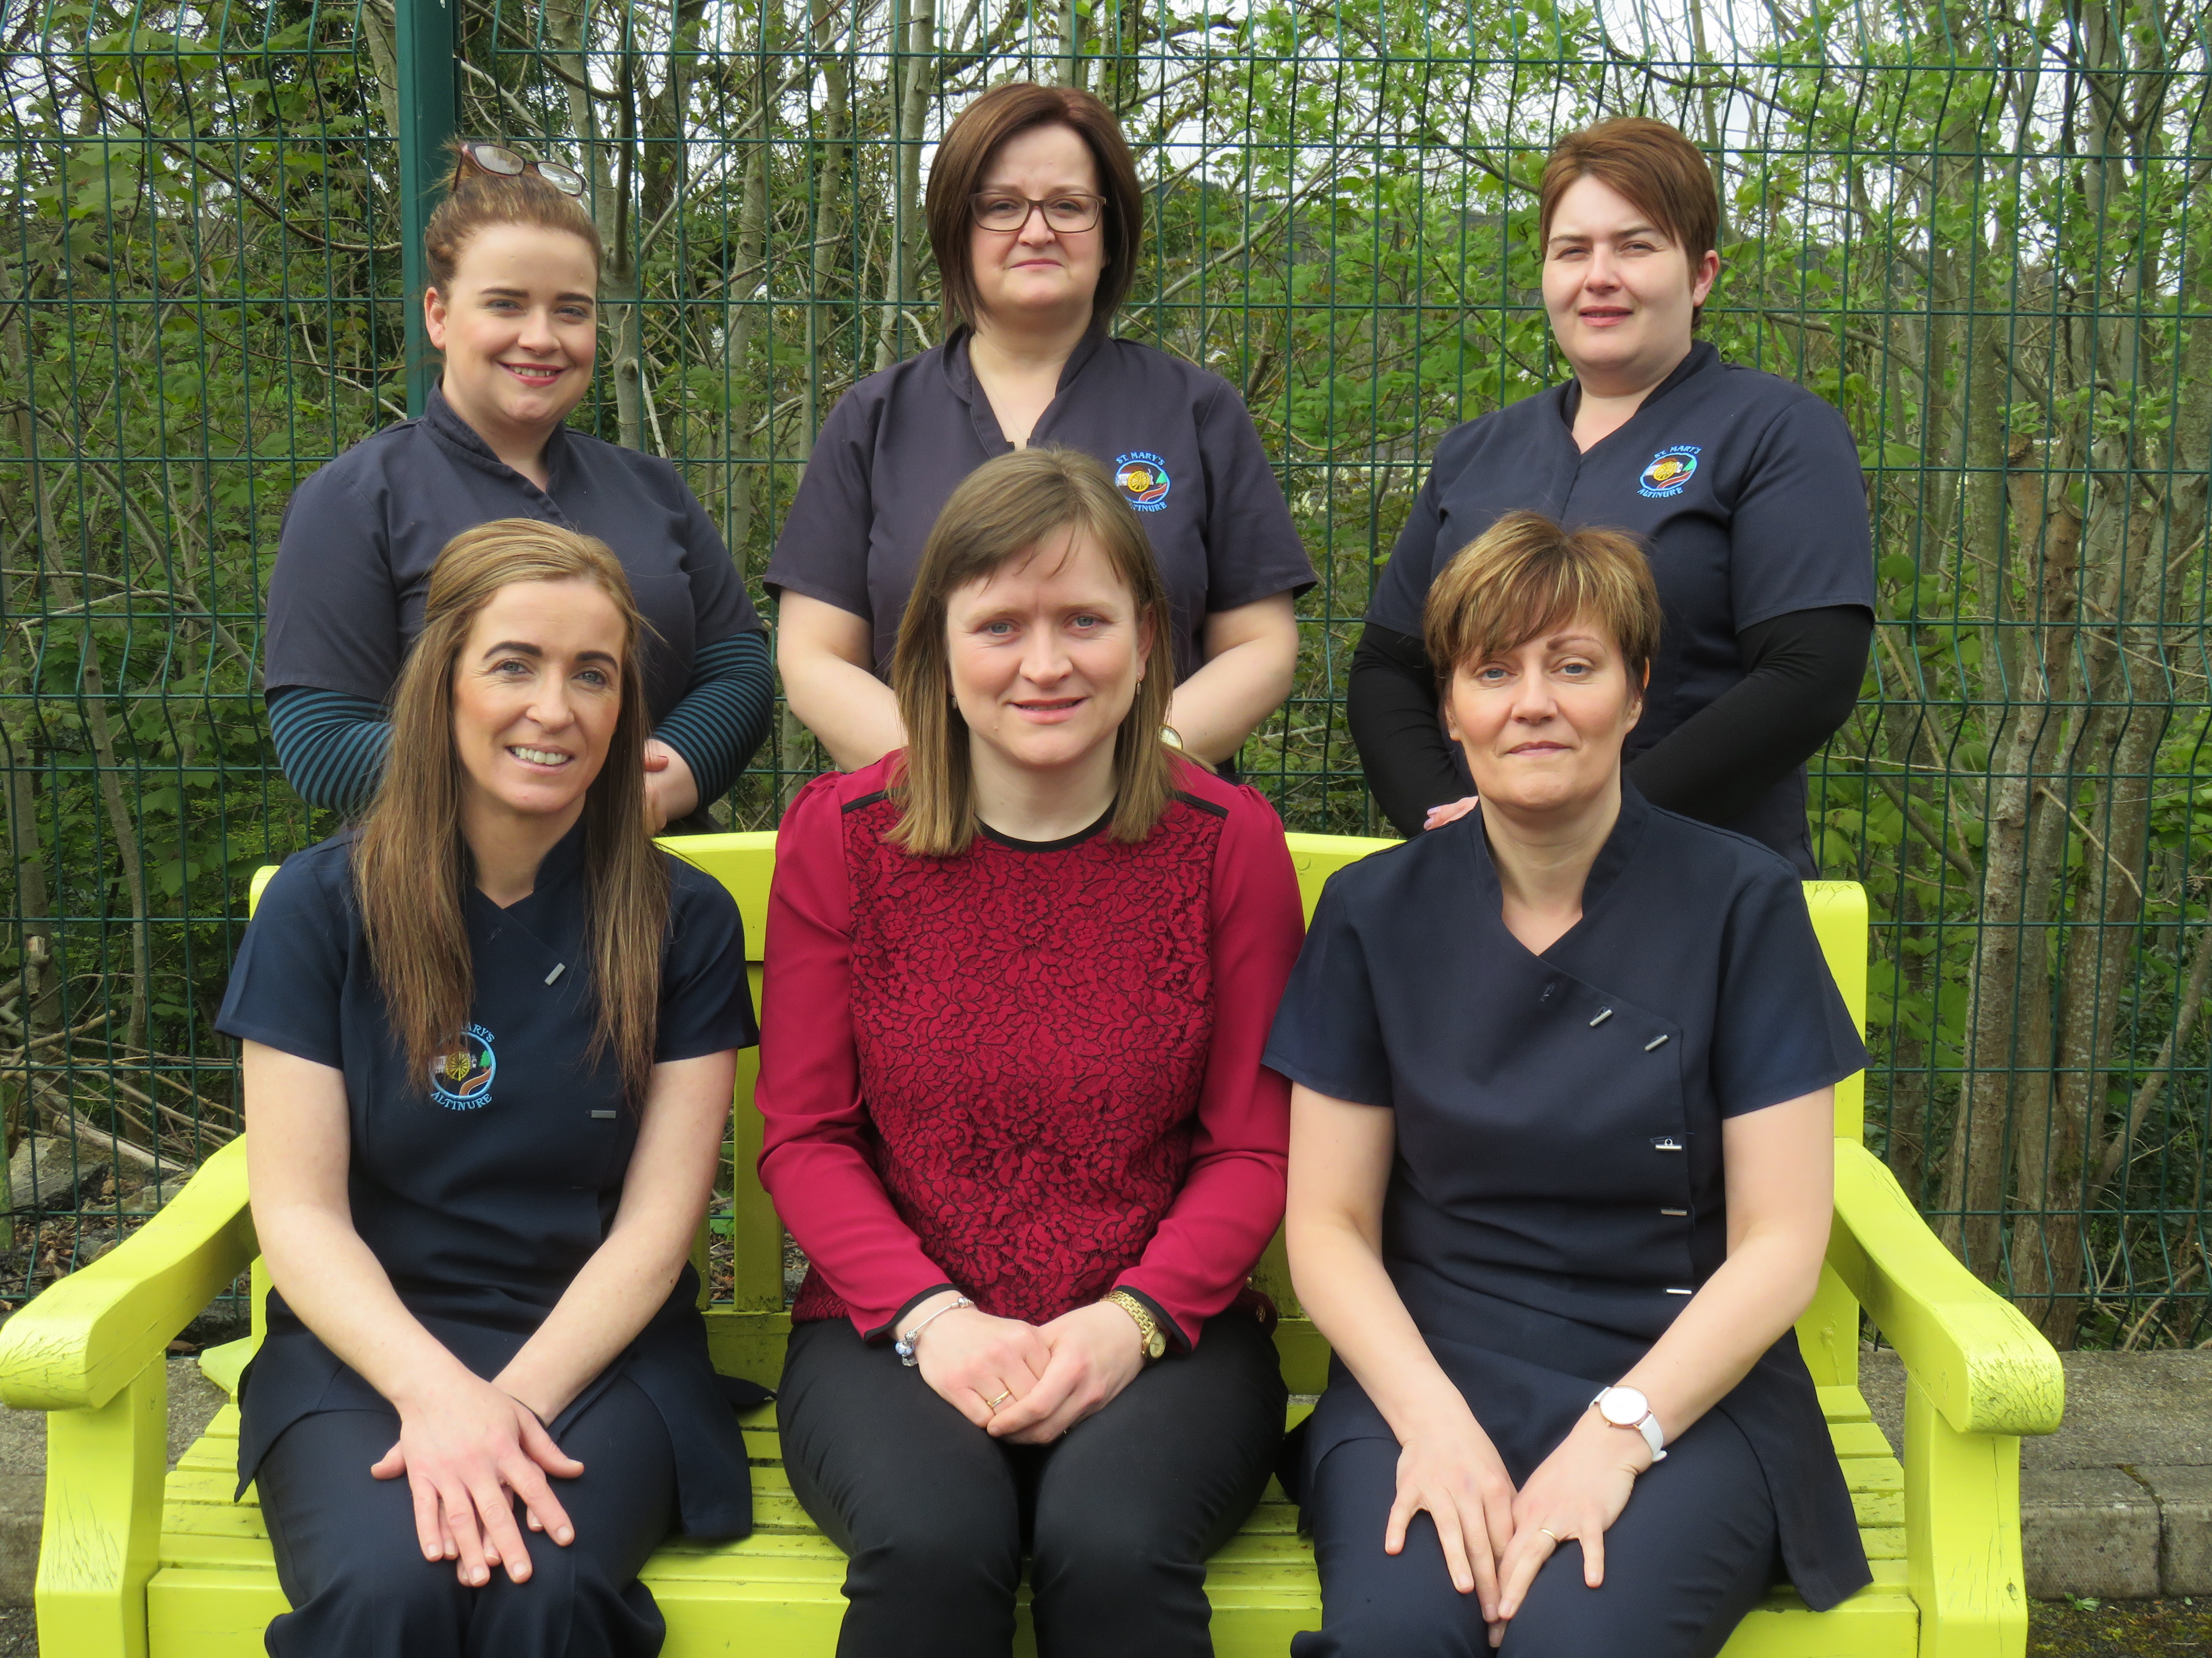

Back from left: Charlene O’Kane, Rosemary Moore & Alice Mc Bride
Front from left: Lisa Coll, Noleen McGlinchey & Pauline McElhinney. (Missing: Shana O’Neill & Lauren McLaughlin)

Canteen Staff
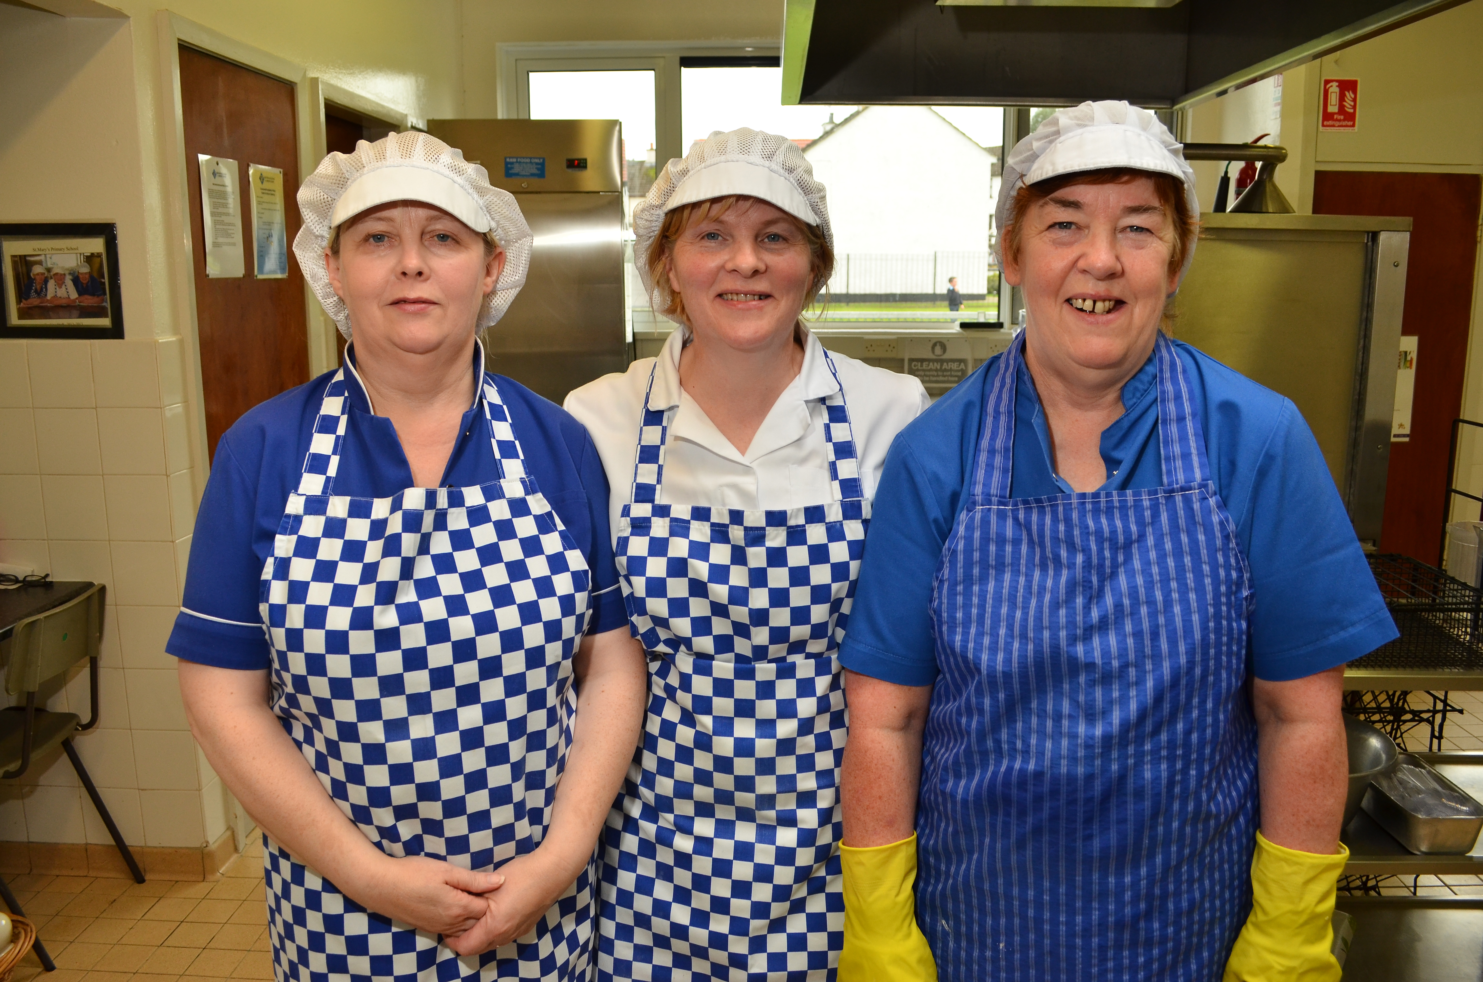

From left: Marie McElhinney, Patricia Feeney, Teresa Conway

Ethos

St. Mary’s Primary school is a co-educational Catholic school situated at the foot of the Sperrin Mountains in the parish of Banagher.
The school’s catchment area includes Park village itself and the Craigbane area of Claudy parish. St. Mary’s is a Catholic school which has strong links with the parish and the community. We welcome children from other faiths.
The school currently has 161 pupils, a Principal and seven teachers, six classroom assistants and a full time secretary. A friendly, caring atmosphere pervades the school and the entire staff and governors are committed to ensuring the highest possible educational standards and provision for the pupils.
We aim to provide a safe and secure environment and children are encouraged to feel good about themselves and have high self-esteem. The school sees a strong link between a child’s self-esteem and his or her academic success and believe that children who feel good about themselves learn more easily. All staff and pupils are valued and achievements are recognised and applauded at every opportunity at assemblies and gala evenings. We use documents such as ‘Together Towards Improvement’ and ‘Every School a Good School’ to support our self-evaluation and development planning.

Our Vision Statement and Aims

As outlined in our vision statement, ‘St. Mary’s Altinure, a family of learners’ we promote a positive ethos, high achievement and learning for life by:

- Instilling in pupils a love for life-long learning
- Developing advanced technological skills for more effective learning
- Motivating pupils to become independent learners
- Building self-esteem and respect for others and their environment
- Being flexible and adaptable for the 21st century

We believe that each child will achieve success through experiencing:

- A broad, balanced and challenging curriculum
- A stimulating and motivating learning environment
- A varied programme of extra-curricular activities and school visits
- An ethos that is supportive, encouraging and friendly
- An effective partnership between school, home and the wider community
- A variety of teaching approaches and strategies to meet the learning needs and styles of pupils
- Access to a range of varied and up-to-date resources

We demonstrate our commitment to working as a learning community through:

- Ongoing self-evaluation to improve on our previous best.
- Working collaboratively with all our stakeholders

School Profile

We currently have 29 pupils (18.01%) on Free School Meals. We will qualify for the Extended Schools Programme in 18-19 as we have 18% of pupils on Free School Meals and 97% or pupils from an area of disadvantage.

Management Structure and Responsibilities within the School

Currently, staffing in the school consists of the Principal, seven teachers and six classroom assistants. Key responsibilities are as follows: Mrs Hegarty - Special Needs; Mrs Redmond – Numeracy; Miss Doyle - ICT; Mrs McAleer - Literacy. These Senior leaders and all other staff have responsibility for delivering the remaining curricular areas.

Teaching and Learning

Our school delivers the Northern Ireland Curriculum through six Areas of Learning: Language and Literacy; Mathematics and Numeracy; The Arts; The World Around Us; Personal Development and Mutual Understanding and Physical Education. In the Foundation Stage, pupils engage in practical activities that are challenging, creative and enjoyable and encourage independent learning. We encourage children’s curiosity and interest in the world around them and motivate pupils to develop Literacy and Numeracy skills in meaningful contexts. In Key Stages One and Two, we build on the experiences provided at the Foundation Stage and promote personal, social and emotional development as well as the development of skills in Communication, Using Maths, Using ICT and Thinking Skills and Personal Capabilities. We seek to establish and maintain the highest standards of education which are in keeping with the aptitudes and needs of individual children and prepare them for further educational experiences and for adult life. We recognise that our well qualified, highly motivated and committed team of teachers and support staff offer quality learning experiences to pupils. The school is a self-evaluating school and, as well as constantly reviewing and improving its own performance, it has sought and gained external recognition on many occasions. Our School aims to develop autonomous learners.
We believe that pupils learn when they are motivated, feel secure and understand the purpose of learning. Our ultimate aim is to develop profound learning.

Our inspectorate report in June 2015 deemed us outstanding in all areas (Achievements and Standards, Provision, Leadership and Management and Child Protection) and the report stated:
‘In the areas inspected, the quality of education provided by this school is outstanding; the quality of pastoral care is also outstanding. The school has demonstrated its capacity for sustained self-improvement.’ (p.5)

Extra Curricular Activities
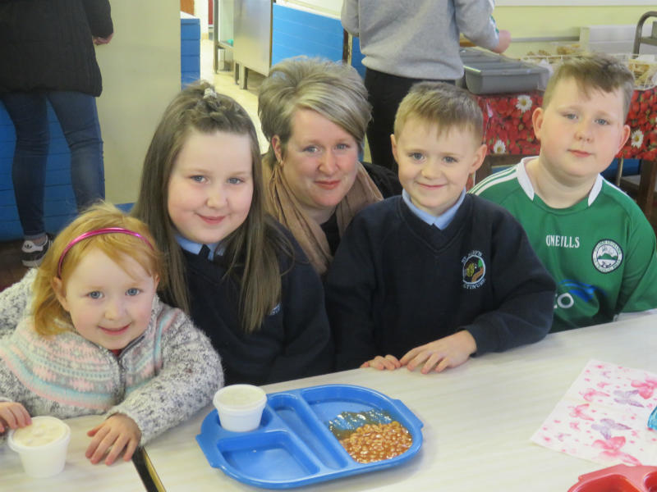

The school provides opportunities for pupils to experience a broad and balanced curriculum, both during school hours and after school. As well as the statutory curriculum, the school offers a variety of enriching curricular and personal experiences for the children. The cultural life of the school is rich and varied, offering each child the opportunity to participate in a range of activities and experiences e.g. Literacy Fair, Road Safety Quiz, assemblies, Christmas Shows, visiting musicians and story-writers.

Celebrating Mothers’ Day Breakfast

The school also provides opportunities for pupils to experience a wide range of sports as part of the physical education curriculum and as extra-curricular activities. The sports activities available include Athletics, Cross Country, Gaelic Football, Hurling, Soccer and Swimming. The variety and details of these activities will change from time to time depending on the expertise and availability of staff.

Health Education is promoted and encouraged through Healthy Breaks, participation in Health Action Awards, Road Safety Awards and numerous health promotion workshops.
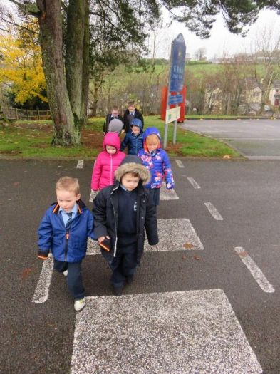
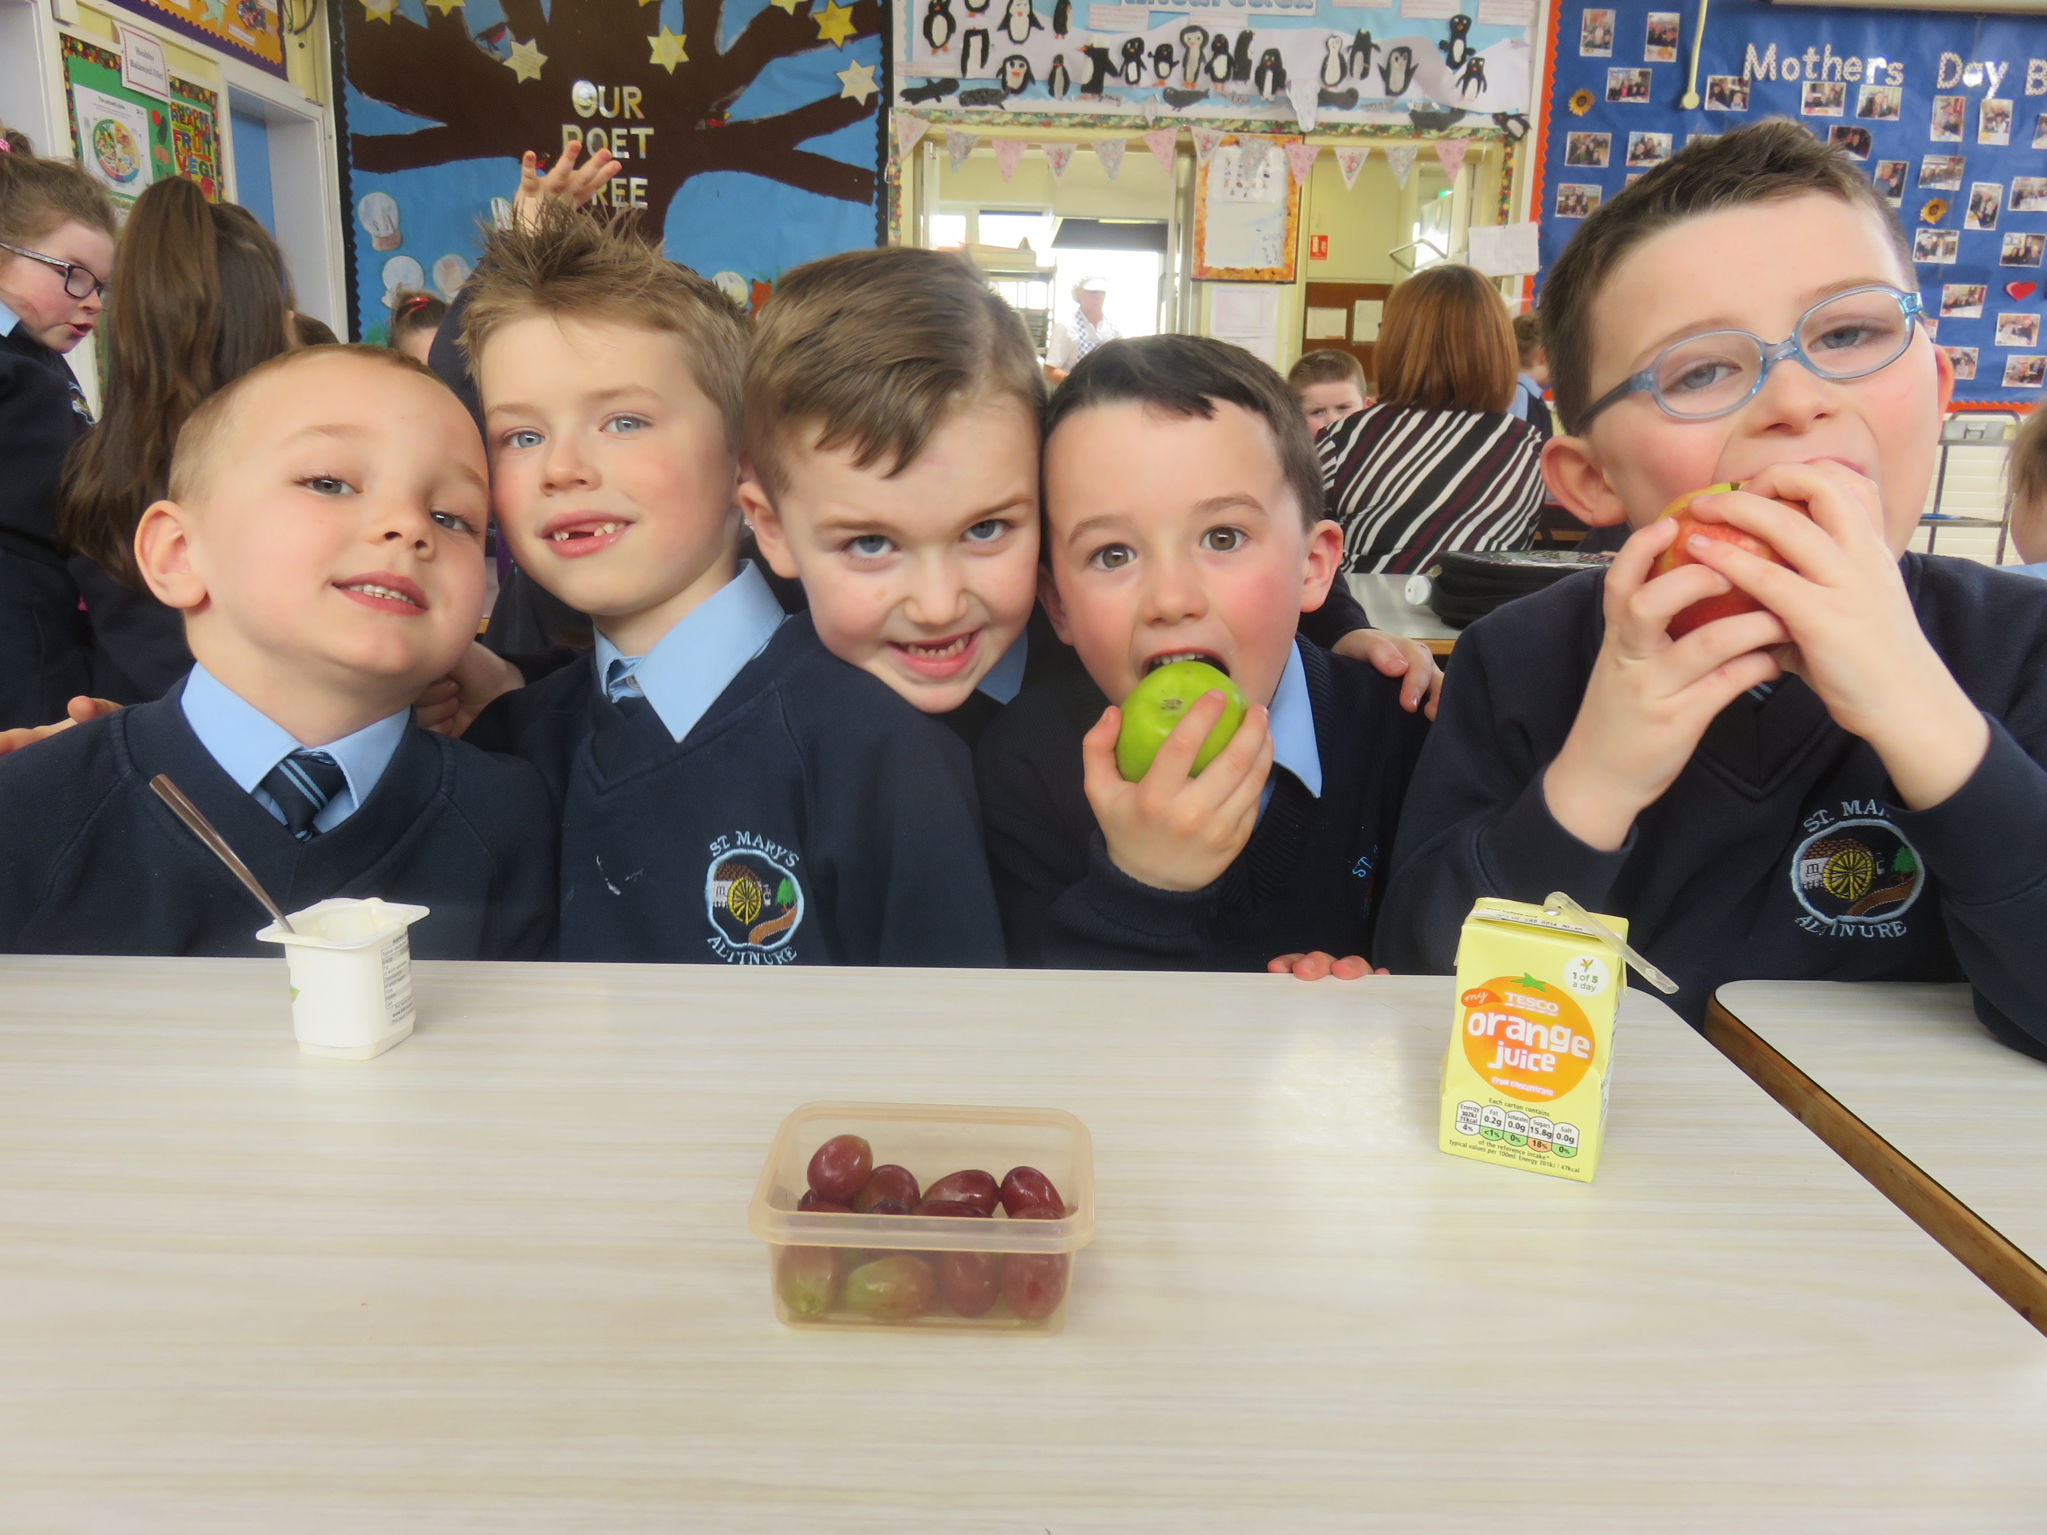
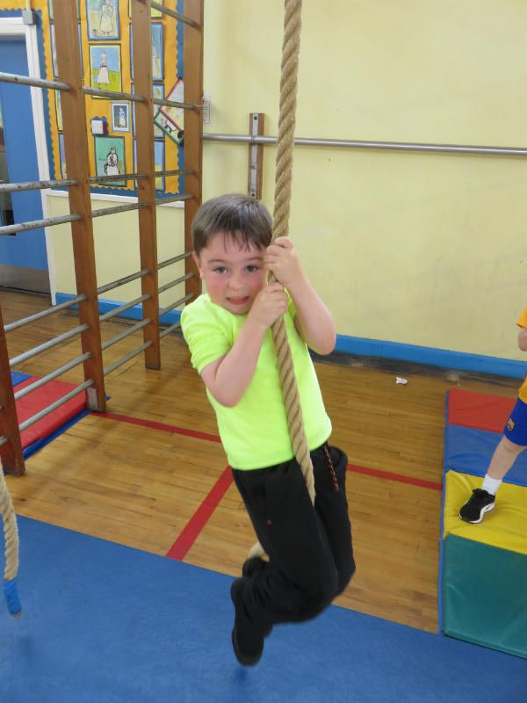
Road Safety lessons in Year 1

Gymnastics in Year 2

Healthy lunches!
Assessment
In St. Mary’s P.S., assessment is an integral part of the planning, teaching and learning process. Teachers use a range of assessment procedures which comply with the age and ability of their pupils. These include regular and consistent marking of written work, observation on a daily basis, weekly class tests and termly unit of work assessments. GL Assessment Baseline Testing is carried out in October and May as appropriate in Year 1. Year 1 and 2 pupils are assessed in Linguistic Phonics and key words as appropriate to determine progress. Year 2 pupils also complete written standardised tests (GL English, Single Word Spelling and Maths). CAT online tests (IQ) are completed by Year 3 - 7 pupils in October. Standardised online tests (GL English and Maths and New Group Spelling Test) are completed from Year 3 - Year 7 in the month of May. End of Key Stage results in Literacy and Numeracy are published in the School’s Prospectus and the Annual Report to parents. Data is collated, analysed and benchmarked against other schools in similar bands and targets are set to improve whole school and individual pupil performance.
Using the computer
to support learning
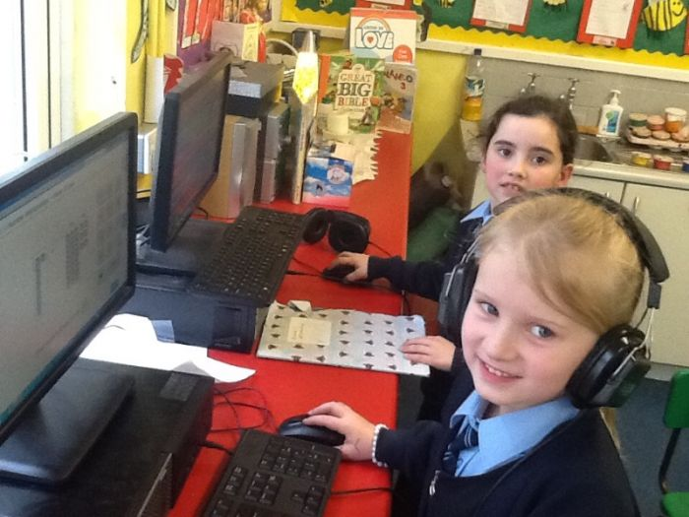
The staff is also committed to the development of pupils’ ICT skills and all pupils undertake ICT Levels of Progression which are internally standardised.

Positive Behaviour

Our school operates a Positive Behaviour Management Programme based on Rules, Rewards and Consequences which is designed to promote good behaviour and raise self-esteem. Positive Behaviour Management promotes the core values of the school as expressed in our mission statement, “St Mary’s Altinure, a family of learners”. It is based on a whole school approach with a strong pastoral ethos and it is adopted by Governors, staff, pupils and parents through a process of consultation. It is dependent on a shared understanding of what is acceptable behaviour among members of the school community. It has effective links with the school’s Anti Bullying, Child Protection and SEN Policies.

Child Protection and Pastoral Care

The Child Protection programme in our school seeks to support the child’s development in ways which will foster security, confidence and independence. As it is central to the well-being of the child, it will form an intrinsic part of all aspects of the curriculum. Children’s self esteem is enhanced through promotion of the ‘Emotionally Intelligent Classroom’ and pupil achievements are recognised at assemblies, on the website and in the school newsletters. We in St Mary’s P.S. have a primary responsibility for the care, welfare and safety of the pupils in our charge and we will carry out this duty through our Child Protection and Pastoral Care Policies. We consult parents on these policies and they are reviewed regularly.
We seek help for pupils with barriers to learning such as family circumstances or emotional problems. New pupils are made welcome in the school especially our Year One pupils who visit the school as part of their Induction Programme in the summer term. Pupils transferring from other Primary Schools are supported by pupils and teachers through close liaison with their previous school and their parents to make this transition as easy as possible.
The welfare of staff is also of prime importance and arrangements for promoting health and well-being of staff are outlined in our Staff Health and Well-Being Policy. Staff satisfaction rates are regularly obtained through staff questionnaires and all staff have opportunities to be listened to and contribute to decision-making through planned meetings. All pastoral and safeguarding policies (Child Protection, Attendance, Positive Behaviour, Anti-Bullying, Health and Safety, Relationships and Sexuality Education, Critical Incidents, Intimate Care, First Aid, the Administration of Medicines, Educational Visits etc…) are available to parents on request.

Drugs Policy

Schools have an important role to play in enabling children and young people to make informed and responsible decisions and helping them to cope with living in an increasingly substance-tolerant society. In St. Mary’s P.S. we have a clear and agreed understanding among everyone in the school community about the implications and possible consequences of drug use/misuse and the important role of drugs’ education. An effective drug education programme is provided in Key Stage Two and our Drug Policy ensures that procedures and protocols are in place should an incident arise. Our Drugs Policy is available on request and is reviewed regularly. It is closely linked to our pastoral care, child protection and safeguarding policies.

Special Educational Needs

In line with the Special Educational Needs and Disability (Northern Ireland) Order 2005 (SENDO), this school believes in an inclusive ethos. We aim to educate all pupils by ensuring access to a broad and balanced curriculum, suitably differentiated to meet individual needs so that all children may achieve their potential.

Where provision beyond what can be given by the class teacher is required, every attempt will be made to provide this by the other staff in the school. If necessary, the specialist services of the Board’s Special Education Section will be used.

Under the guidance of the Special Needs Co-ordinator (SENCO) Mrs AM Hegarty, staff follow procedures for early identification of children with specific learning difficulties under the terms of the Code of Practice for SEN. We currently have six pupils with statements of Special Educational Need.

We encourage parents to work closely with us in supporting children with learning difficulties and involve them at each stage of the process.

Individual programmes of support are implemented using differentiated teaching materials, one to one or small group sessions with the SENCO, a designated Classroom Assistant or external agencies where appropriate (e.g. Reading Centre/SEBD service/RISE team/ Foyle Down’s Syndrome Trust Support teacher). Individual Education Plans are prepared in liaison with the child’s parents and plans are reviewed once a term. The child’s progress is closely monitored by the class teacher and SENCO and the parent is kept informed.

Our Special Needs Policy is updated annually and is available on the school website/on request.

Attendance
All attendance is recorded on our computerised attendance register for both the morning and afternoon sessions. We have excellent pupil attendance figures in St Mary’s Primary School, Altinure, (currently 97%) and we acknowledge full attendance annually with school and EA Certificates. All children should attend school for the 190 days which the law requires, unless they are ill. If children have to miss school, for illness or any other reason, lasting more than a day, then parents should telephone the school or send in a note explaining the absence.
We liaise closely with the Education Welfare Officer regarding pupil attendance and she has full access to pupil attendance statistics at any time. Pupil percentages are reviewed termly in
conjunction with the EWO. Pupils whose attendance has fallen between 85 and 90% are issued with a school letter to encourage improved attendance. Pupils whose attendance has fallen below 85% must be formally referred to the Education Welfare Officer.
The Teacher Attendance Procedure has been adopted by the Governors to promote attendance and teacher welfare and ensure that teachers are treated fairly, consistently and with sensitivity during times of illness. The Principal and BOG liaise closely with CCMS to manage teacher attendance. The EA Managing Attendance at Work Policy is also adhered to by the Governors as this provides a clear framework for managing ancillary staff absence at local level.

Staff Development

Staff development is the process of staff learning which aims to increase the effectiveness of all

staff and governors both as individuals and as team members. It thus enables them to contribute to the school’s vision and goals and to fulfill its guiding principles. The staff development process will ensure mutual benefit for the individual and the school.

All staff development activity is planned in the context of the school’s vision, goals and guiding principles. Staff development needs are identified through an annual skills audit together with PRSD. Resources are prioritised to achieve school goals. Financial and other resources for staff development are allocated annually and apportioned in accordance with school priorities for strategic development, continuing professional development and succession planning.
Board of Governors
A Board of Governors meeting takes place at least once per term and the Governors are involved in the preparation of the School Development Plan and the monitoring and evaluation of this Plan. A review of the previous year’s plan is carried out in May each year and the priorities for development agreed by SLT, Co-rdinators and staff and these priorities are then approved by the Governors in October. A three year plan is prepared, currently spanning the years 17-20, and yearly Action Plans are produced. The Principal and Co-ordinators report at the Board of Governors meetings on progress within the plans and an end of year written evaluation of teaching and learning is presented by the Principal to the Governors and Staff. The Governors are informed of any amendments to the plans during the year or over the three year period. Whole school standards are communicated to the Board of Governors on an annual basis and results are benchmarked against schools of similar bands.

School Partners

(a) Parents

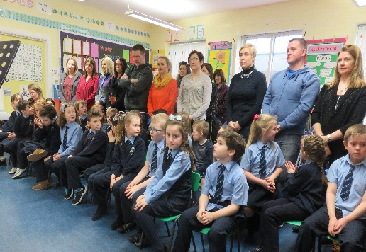
Parents are our partners in educating children and we welcome and plan for parental involvement in their child’s education. Communication with parents is maintained on an ongoing basis through the use of the school website, assemblies, monthly newsletters, Governors Annual Report, School Prospectus, Parents’ Noticeboard and Annual Report to parents. There are also formal meetings with parents at least once a year, usually in October. Parents of pupils on the Special Needs Register are in contact more frequently to discuss Individual Education Plans. We also communicate through Induction, Linguistic Phonics, Transfer and School Trip meetings as well as meetings to discuss curriculum areas. Parents of Year 4 and Year 7 also attend a Parish meeting to help them to prepare their children for the Sacraments of First Confession, First Communion and Confirmation. Year 4 parents attend a First Communion Enrolment ceremony. Parents are represented on the Board of Governors by a Parent Governor. Our Parents Association, Friends of St. Mary’s P.S., organises fund raising events and the principal takes on board the view points of members when making decisions.

Parents are consulted about the effectiveness of the school through questionnaires which are completed in a three-year cycle. Questionnaires are also issued during anti-bullying week and following school initiatives such as Shared Education.

Parents are consulted in the development of relevant policies such as the E- Safety and the Use of Digital Devices Policy, Anti- Bullying Policy, Positive Behaviour Policy, Child Protection Policy, Relationships and Sexuality Education Policy and the Parental Complaints Procedure. We also avail of our parents’ expertise to support curricular areas such as The World Around Us, STEM and the Arts.

Year 4 Parents Attending the

First Communion Enrolment Ceremony

(b) Pupils

Pupils are highly involved in their learning. At the beginning of each school year, pupils help to devise their own class rules, rewards and consequences as part of the school’s Positive Behaviour Programme. They contribute to the topic based learning approach by expressing their views and ideas on what they would like to study. All pupils are encouraged to self review and set personal targets and pupils on the Special Needs Register are consulted about their IEPs. Pupils are also involved in decision-making processes within school through class councils, the eco-council and various questionnaires.

(c) The Community
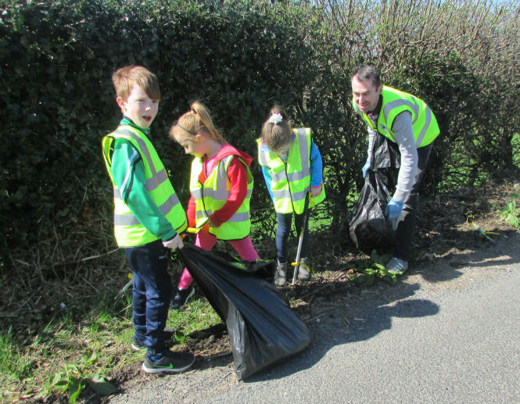

The school maximises opportunities to make links with the community. Members of the community have been elected to our Board of Governors and have specific areas of responsibility eg Child Protection and Health and Safety. We work closely with the Learmount Community Group and use the Local Recycling Centre, Resource Centre and people from the local community to support the curriculum. Local businesses and sports clubs sponsor school events and we cluster with other Primary Schools to share expertise and generate new ideas. We link with Park Community Playgroup to ease transition of pupils from Playgroup to Year One. We also work closely with local Post-Primary Schools to ease transition for Primary Seven pupils. We collaborate with many different agencies such as CCMS, DE, CCEA, EA, the Reading Centre, RISE, CAMHS, Psychology Service, Health Service, PSNI, Fire and Ambulance Service, Public Library Service, RAPID and Derry City Council to enhance the curriculum and support pupil needs.
Our Annual Community Spring Clean!

We also fund-raise annually for various local and global charities. Our school is also available to the community for social events.

Shared Education

The school has worked closely with Cumber Claudy Primary School for many years through CRED and Shared Education projects. In 18-19, we will begin the fourth year of a STEM based Shared Education programme with Cumber Claudy P.S. All classes annually link with their equivalent Year group for a fun educational activity such as a Forest School lesson, trip to an exhibition or a Science workshop. Year 5 & 6 will continue to participate in a STEM programme through which pupils from both schools will develop friendships while developing their skills in STEM (Science, Technology, Engineering and Maths). This project extended also to Year 7 pupils in the 17-18 year. The Shared Education programme is also building capacity within staff of both schools through cluster meetings and the provision of professional development opportunities.

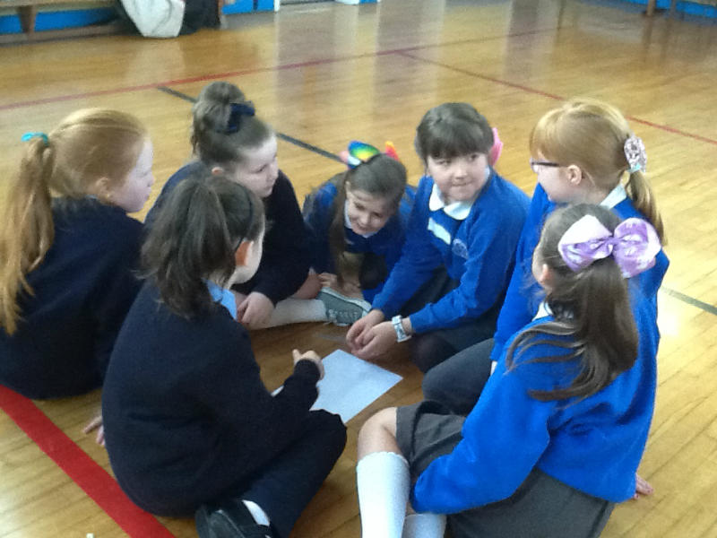
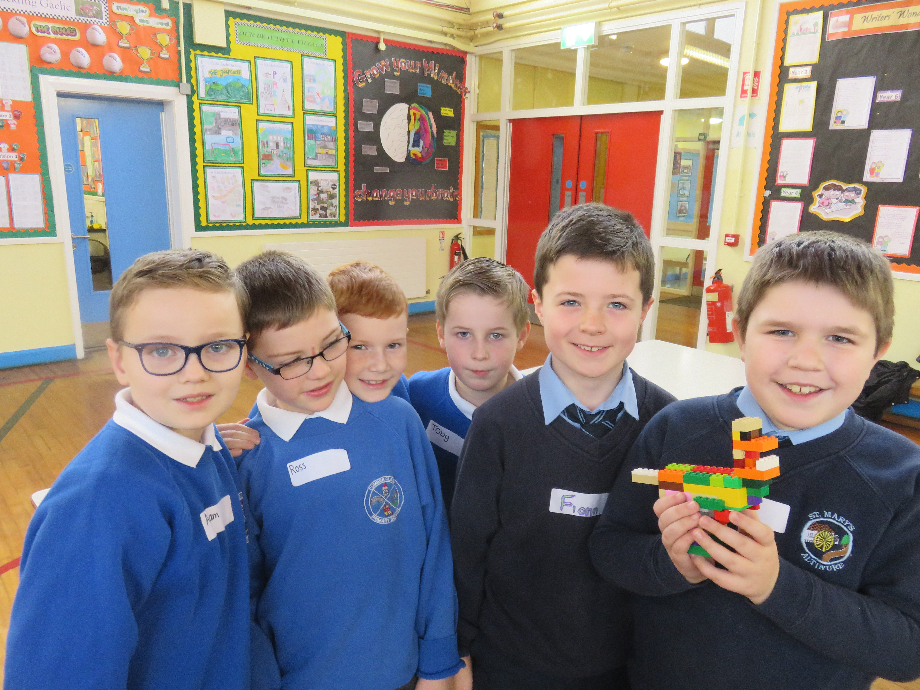

STEM Lego workshop

through Shared Education

Shared Education PDMU sessions in Year 6

Finance

At the end of the past financial year (April 17), we closed with a surplus of £18,377. This covered the cost of seven full-time permanent staff, one part-time permanent staff member and one temporary teacher. However, due to financial constraints, the projected financial plan for 17-20 will involve a reduction in the teaching complement. A detailed outline of the School’s Financial Position and Projected resources for 17-20 can be made available on request.

Sustainability
We are committed to the promotion of Sustainable Development and aim to develop in our young people the knowledge, understanding, skills and values to help them make their own informed decisions relating to the world around them and be willing to take appropriate action. Planning is carried out using a thematic approach which provides opportunities for connected learning and incorporates issues affecting the economy, society and the environment, now and in the future. St. Mary’s is an Eco School and we were re-awarded our Green Flag in March 2018. We continue to strive to promote health, links with the community, energy efficiency and management of waste and resources.
Awards
St. Mary’s seek external accreditation to promote the profile of the school within the community and secure our sustainability. The external assessment processes enable us to reflect on current practice and self-evaluate which informs future planning. Pupils are encouraged to enter competitions at individual and group level which fosters self-esteem as well as achieving recognition for the school. Competitions include sporting blitzes, Road Safety and Public Speaking events, the Derry Feis and the Johnny Burke Fleadh among others.
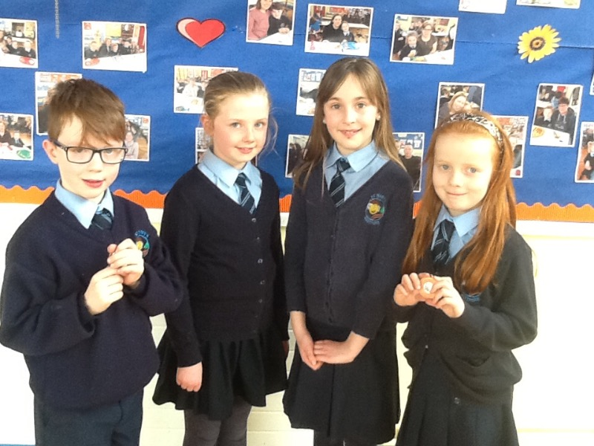
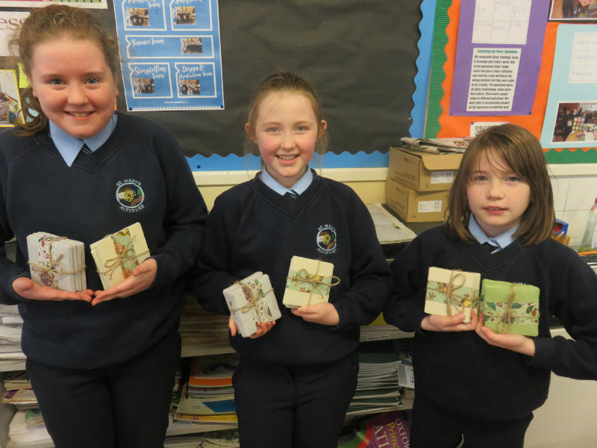

Junior Entrepreneur Business Project
in Year 7

Year 4 winners –

the Johnny Burke fleadh

Challenges

With a decrease in local employment and average family size, we have experienced a small decrease in class sizes in Key Stage One. We strive to maintain our enrolment by positively promoting our school in the community, involving parents and partners at every opportunity and ensuring that we provide a high standard of education by constantly reviewing and improving our teaching and learning. Due to financial constraints, we anticipate a reduction in our teaching complement and the introduction of composite classes in 2018/19. All teachers are implementing the Northern Ireland Curriculum and the establishment of selection examinations in post primary schools is also a consideration in Key Stage Two. Declining budget allocations have impacted on resourcing but we have built up excellent resources over the years and can therefore still deliver a high quality education. CASS training and support are also limited now due to education cutbacks but we avail of all appropriate opportunities for training to ensure teachers are kept abreast of educational changes. The provision of a Special Needs teacher is now financially difficult to sustain so we aim to maximise opportunities to provide this necessary support using Foundation Stage teachers in the afternoons and with provision of SEN support from classroom assistants and external agencies such as the Reading Centre, Play Therapists and the SEBD service.
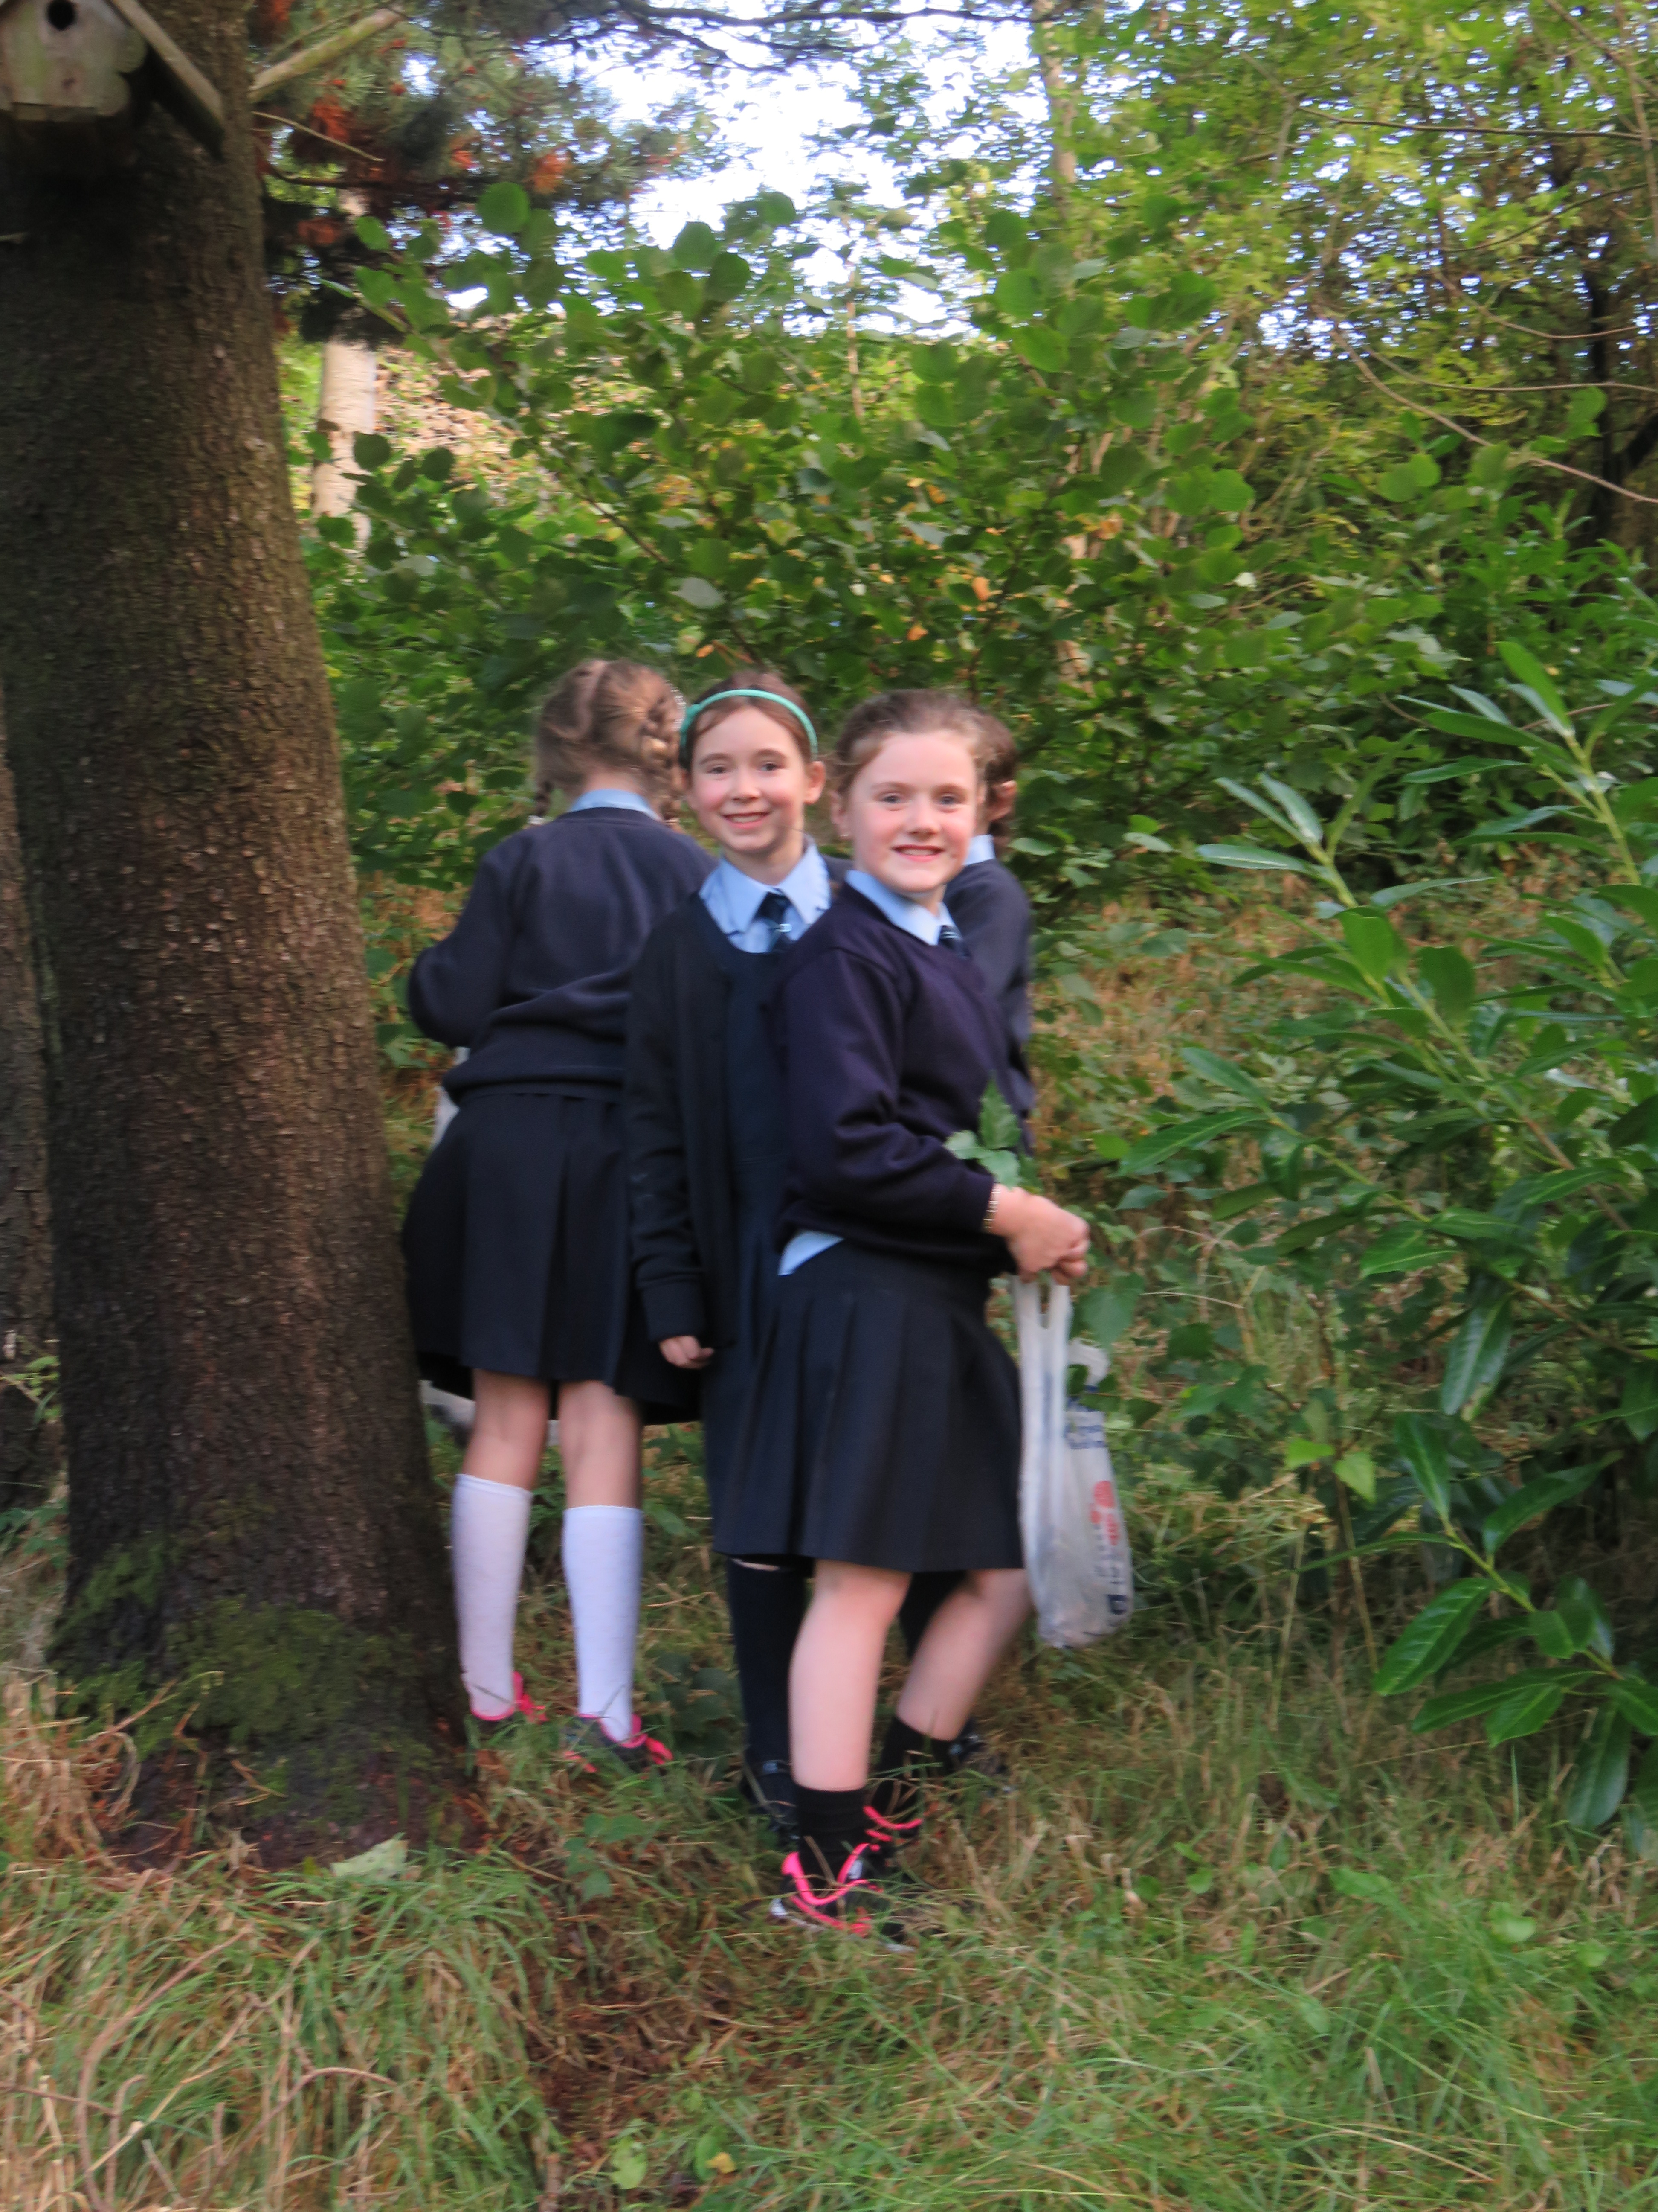
Opportunities

All pupils learn Irish as Mrs G. McKenna, a retired Irish teacher, volunteers in our school, teaching all classes once a fortnight. We encourage Key Stage 2 pupils to participate in both internal and external Road Safety quizzes in order to improve their communication skills and enhance their self esteem.

Musical Pathways currently takes place in all classes at different times of the year. Two staff members have been trained as Forest School leaders and lesson plans and strategies from Forest School have been shared with all staff so that pupils in all classes enjoy the benefits of the outdoor classroom. We have also developed our school woodland, Little Learmount, as a valuable area for play and to facilitate outdoor teaching and learning. We work closely with Council representatives, RAPID and environmental agencies to maximize opportunities for outdoor learning and we link through Shared Education with staff members from Cumber Claudy PS who have also been Forest School trained.
Outdoor learning in Little Learmount!

Schools Council/ Eco-Council

Involving pupils wholeheartedly in decision-making processes is very important to us at St. Mary’s P.S. We have regular class council meetings where pupils make suggestions on how to make our school a better place. Voted representatives from each class then report to our School’s Council where appropriate actions and decisions are made.
Primary 1 – 7 pupils are also represented on our Eco-council where pupils carry out environmental reviews and monitor energy and water consumption in order to become more environmentally friendly. They record amounts of recycling and litter collected around the school grounds and report back to classes at assembly on ways to improve how environmentally-friendly we are as a school.

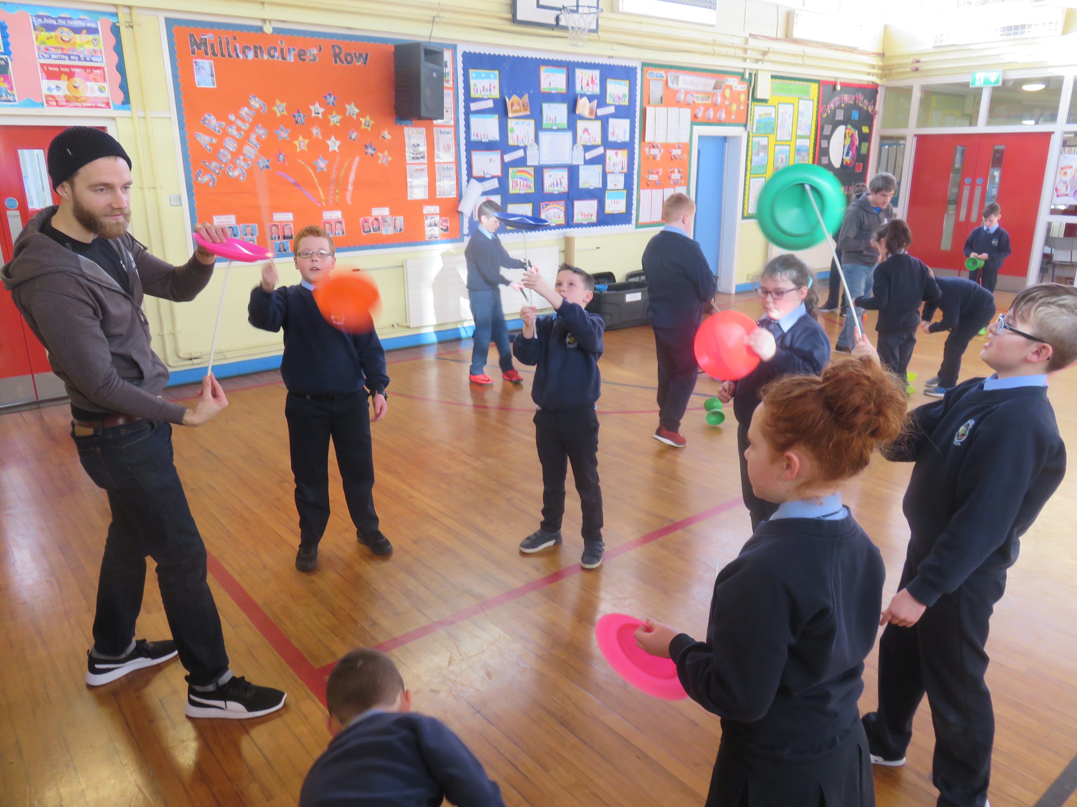
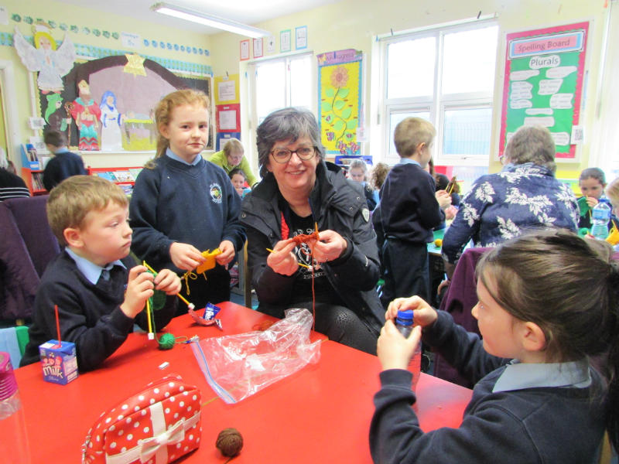

Circus skills in Year 6
Knitting with the 60+ Group

External Recognition
Eco-Council – Proud Winners of the
Eco-Schools Green Flag – March 18
14-15

North Derry Cumann Na mBunscoil Gaelic Championship – January 2014 – Winners
All county Gaelic Finals - Finalists – March 2014
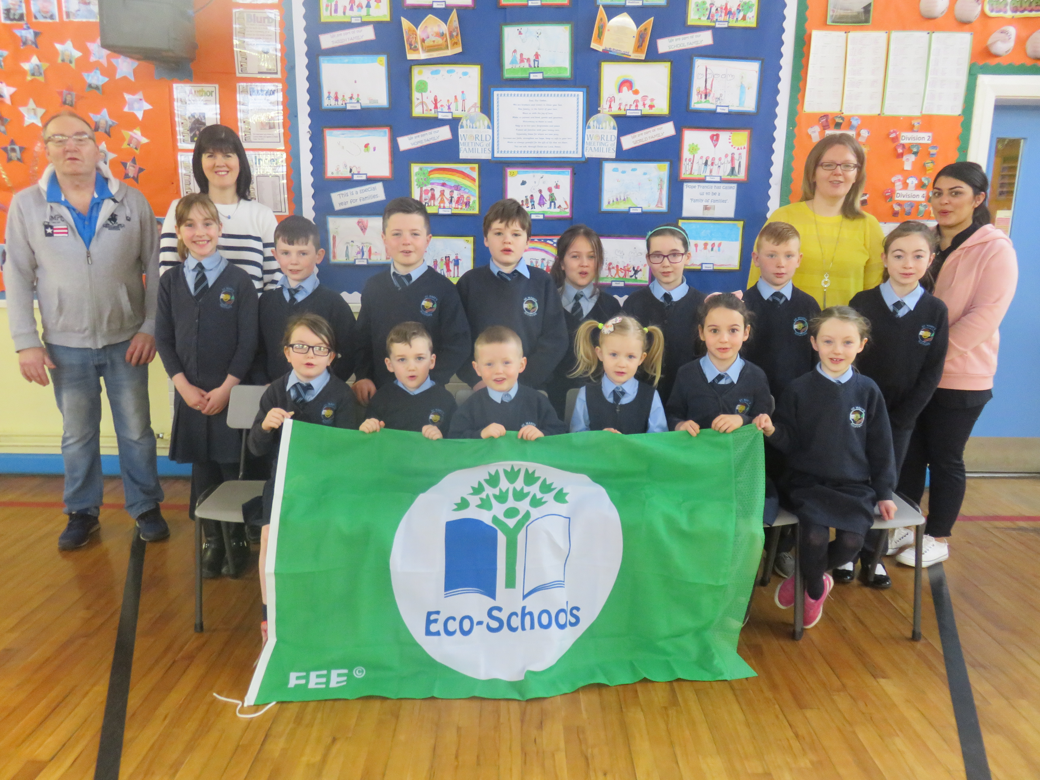
Foyle Home Accident Prevention Public speaking – 2nd place March 2015
One pupil picked to play for under 11 N.Ireland Youth Squad
Road Safety Quiz – Finalists – March 2014
One pupil qualified for N.Ireland cross country Finals. – February 2015
St Columb’s College Game 24 competition – overall winner
Health Action Award - Silver
Eco-Schools Green Flag Award
Outstanding ETI Inspection

15-16
Derry and Strabane Road Safety Quiz Winners

Miss U Doyle – NI Road Safety Awards – Highly Commended
Year 7 - Runners up in Road Safety Quiz (Derry). NI finalists.
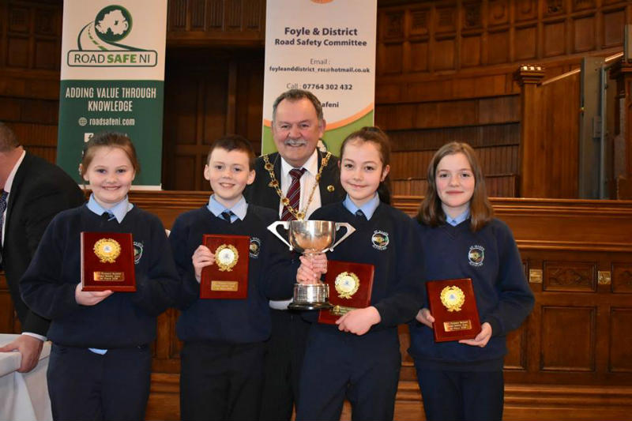
Year 7 – NI overall winners in Road Safety Quiz final - Belfast
Yr 5 pupil – shortlisted in Ireland in 2016 art competition
Yr 7 - awarded Junior Entrepreneur status- Flag
Best Kept School Award – Regional winner – Western Region
Conor McCartney Road Safety competition – 2 pupils first place and 1 pupil 3rd place
Sentinus Junior Industry Big Bang Award – second place June 16
Home Accident Prevention Award – Year One – 1 winner
Health Action Gold Award – June 16

16-17
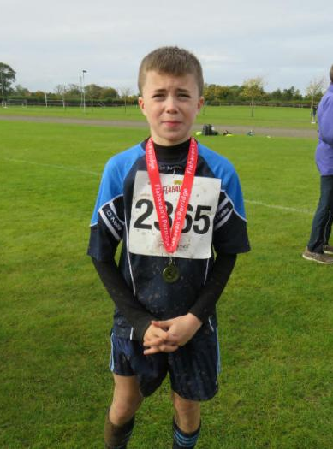
NI Cross Country finalist – Year 6 pupil - Feb 17
Diabetes UK Award - Feb 17
Year 7 pupil-
NI cross country finalist
Unveiling Yr 6 Art Work, Dublin National Gallery - Apr 17
Johnny Burke Fleadh- winners- various categories - Mar 17
Road Safety Poster competition - May 17
Health Action Silver Award - May 17
RAPID Art project – first place – May 17

School Hours

The school day begins at 9.20 a.m. and children should be in their classroom by this time. Children can arrive at school from 8.30a.m. and they are supervised in the assembly hall until they are collected by their teachers at approx.. 9am.
All children have a supervised playtime for 10 minutes in the morning from 10.50 – 11am.
The lunch-break is from 12.20 p.m. - 1.00 p.m. The Primary 1 and 2 classes finish their school day at 2.00 p.m. and Primary 3 – 7 classes finish their school day at 3.00 p.m.

School Term and Holiday Dates

Below is a list of all the holidays for school year 17-18.

Term One
30th Oct – 3rd Nov – Hallowe’en holidays
Half day – 20th Dec. Christmas holidays.
School reopens Mon 3rd Jan.

Term Two
Our KS1 Christmas show,
‘The Stars Come Out for Christmas’
Mon 12th –Fri 16th Feb – mid-term break
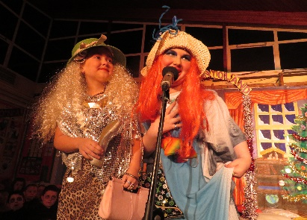
March 19th – St. Patrick’s Day

28th March – half day. Easter holidays.
School reopens Mon 9th April

Term Three
Monday 7th May
Mon 28th and Tues 29th May – Staff Development Days
Half day 29th June – Summer holidays

Our KS2 Christmas show,
‘Panto Pandemonium’

Communication Key Stage Results 16-17

 | Key Stage One |  |  |  | Key Stage Two
Levels | W | 1 | 2 | 3 | W | 1 | 2 | 3 | 4 | 5
Our  School |  | 4.3% | 78.2% | 17.39% |  |  |  | 15% | 50% | 35%

Using Maths Key Stage Results 16-17

 | Key Stage One |  |  |  | Key Stage Two
Levels | W | 1 | 2 | 3 | W | 1 | 2 | 3 | 4 | 5
Our  School |  | 4.3% | 65.2% | 30.4% |  |  |  | 5% | 30% | 65%

School Leaver’s Destinations

Year | Number  Leaving
 |  | St Columb’s  College | Thornhill  College | St Pat’s  Maghera | Lumen  Christi | St Pat’s &  St Brigids | Other
2012 | 30 | 3 | 5 | 0 | 2 | 20 | 0
2013 | 29 | 4 | 6 | 0 | 4 | 14 | 1
2014 | 30 | 9 | 8 | 1 | 0 | 12 | 0
2015 | 28 | 7 | 7 | 1 | 6 | 7 | 0
2016 | 27 | 9 | 9 | 2 | 3 | 4 | 0
2017 | 20 | 5 | 6 | 0 | 4 | 5 | 0

Records of Achievement

A record of progression is collated for each child containing samples of work from Primary 1 – Primary 7. In Primary 7, children compile a portfolio of work, which is a celebration of their personal achievements, skills and talents (both academic and non-academic, inside and outside the school) called a Record of Achievement. These are formally presented to the children at our Annual Presentation evening in June of the summer term.

Religious Education
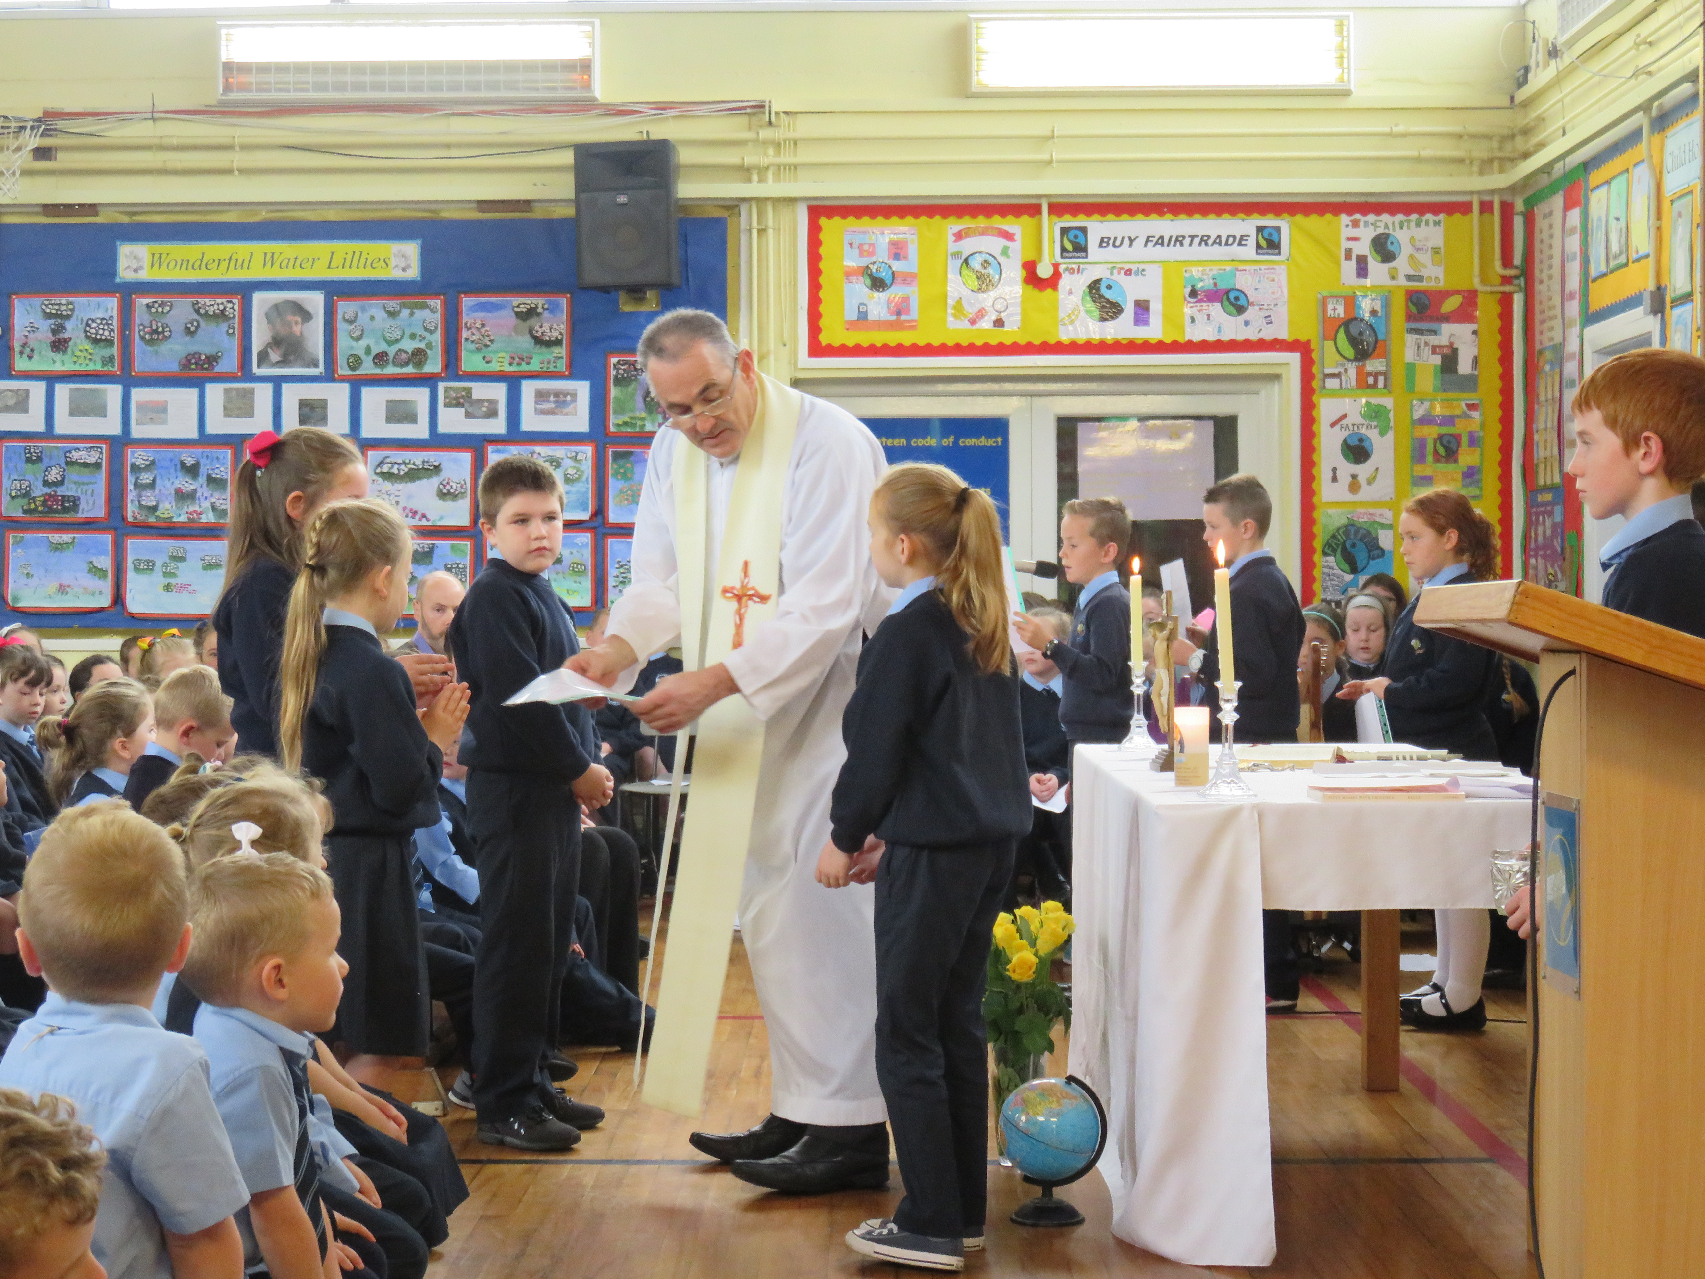
The school is committed to the creation of a believing community, committed to living out in its daily operation the Christian way of life. Each child will be encouraged to get to know Christ as a person and follow the way of life he taught by word and example. A carefully structured Religious Education programme – The Grow in Love Series – is being phased into our school, supplemented with the Alive O scheme and other resources. Children are prepared for the sacraments of Reconciliation, Eucharist and Confirmation. Year 4 and 5 pupils participate in Adoration in St. Mary’s Church once a month. Strong links between home, school and parish are encouraged. We also support the local church by organizing altar servers to assist Fr Baker, Fr O’Connell and Fr Collins at weekend masses.
Mass for the opening of the school year

Homework and Accelerated Reading

All members of staff believe that homework can play an important part in the education process. It allows pupils to practise, apply and consolidate what has been learnt in school and at the same time facilitates parental involvement in the child’s learning.
The type of homework set will range from informal and practical tasks in the Foundation Stage to a more formal arrangement in the Key Stage 1 and 2 classes. Each class teacher will decide on the most appropriate tasks in his/her class and will take into consideration the needs and abilities of the pupils. Parents and teachers need to work in partnership to encourage effective learning.
Homework tasks will generally cover a wide range. Children will be asked to research topics, make observations, gather and record data, collect materials and conduct interviews. They will sometimes be asked to practise musical instruments, learn spellings or tables, create posters or practise handwriting.
At all times, children will be encouraged to take home books to read. Pupils from Year 3 – 7 will participate in the Accelerated Reading Programme where pupils can read books and do computer quizzes related to the stories. Children are awarded points and prizes according to their successes and achievements are also recognized at school assemblies. Parents will be encouraged to try to find the time to read with their children and to discuss their books with them.

Year 3-7 pupils also participate in Mathletics. Teachers assign tasks to pupils who enjoy accumulating points and earning certificates by completing Maths challenges. Mathletics is an optional alternative to written Maths homework once per week. Parental support and encouragement is vital for the success of the homework programme.
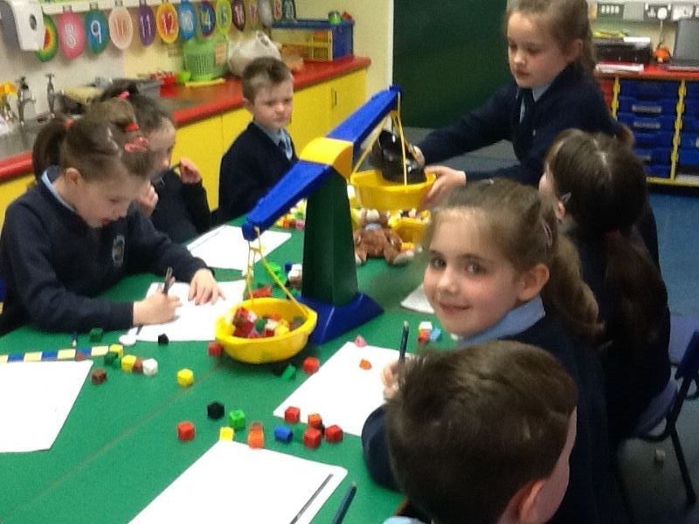

Winners of our Road Safety Poster Competition with our Junior Road Safety Officers
Practical Maths - weighing in Year Two

Uniform
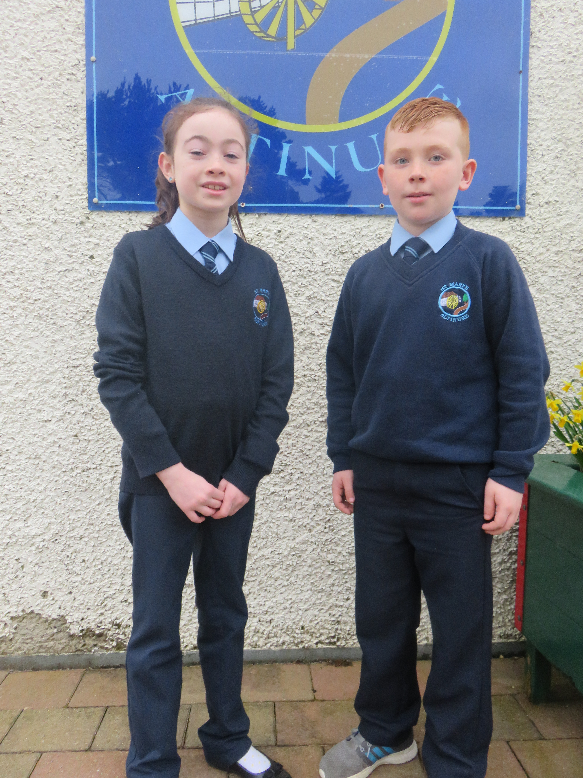

Boys Navy trousers
Navy jumper with school crest
Pale blue shirt and school tie

Girls Navy skirt/pinafore or trousers
Navy cardigan or jumper
Pale blue blouse and tie

Footwear Black shoes/ trainers
Looking good!

School uniform can be purchased from Select Schoolwear or Ferguson Fashions, Derry. Please ensure that all clothing is labelled clearly with your child’s name and class. Children are discouraged from wearing jewellery to school for Health and Safety reasons. Stud earrings are acceptable for girls. There is no specific PE uniform requested – shorts/tracksuit bottoms and T-shirts/jerseys are acceptable. Proper footwear with effective grips on the soles are essential for PE. Please ensure your child brings a PE uniform on the appropriate days.

School Rules

Children are expected to behave in a way which shows consideration for other people and their property. We expect them to treat both other children and adults with politeness and kindness and to have a regard for the safety of themselves and others. It is expected that pupils make good behaviour choices at all times in school, on the bus and on school outings.

School Milk

Milk can be purchased by those who wish to have it at breaktime. The charge is currently £4.00 per month and it is due at the beginning of each month.

Credit Union

Pupils can avail of a Credit Union Saving Scheme. Books and monies are collected every Tuesday.
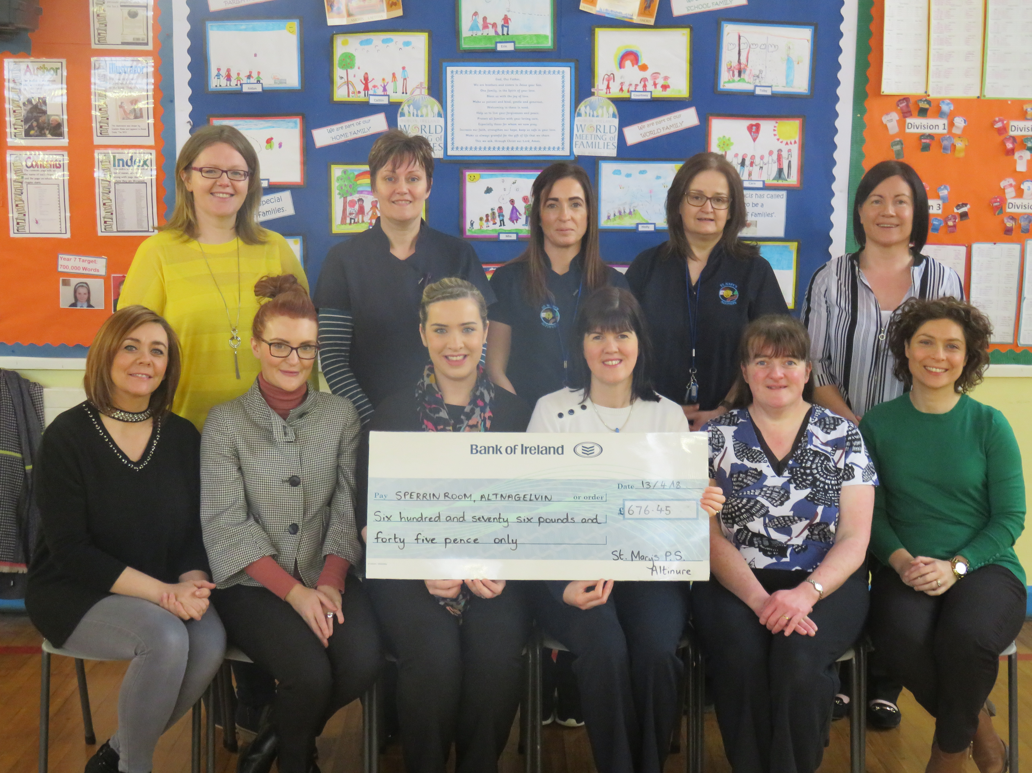

Staff presenting cheque for
Sperrin Room, Altnagelvin
Measuring rainfall in Year 7

Admissions Procedure

If you wish to enroll your child in St Mary’s Primary School, Altinure, you must complete an application form (available from the School Secretary) and return it with your child’s birth certificate to the school.

For admission into Year 1 in September 2018, applications should be made before Wednesday 10th January at 12 noon.

Parents of Year 1 children will receive an invitation to our Pre-School Induction Programme in May/June at which they will receive a Sure Start Pack. Teachers Mrs Hegarty and Mrs McKenna provide details about many aspects of school life and your child will get an opportunity to meet his/her teacher in what will be his/her first classroom. The opportunity to see around the school can be availed of at this time.

School Year  (Year One pupils began) | 2006-07 | 2007-08 | 2008-09 | 2009-10 | 2010-11 | 2011-12 | 2012-13 | 2013-14 | 2014-15 | 2015-16 | 2016-17 | 2017-18
No of applications | 30 | 30 | 25 | 26 | 22 | 25 | 20 | 22 | 21 | 21 | 32 | 15
No accepted | 30 | 30 | 25 | 26 | 22 | 25 | 20 | 22 | 21 | 21 | 32 | 15

Admissions Criteria – Year 1

Respective functions of the Board of Governors and Principal in relation to admissions.

The Board of Governors of St Mary's Primary School, Altinure has determined that the following criteria shall be applied by them in the event of the number of pupils applying for places in Year 1 being greater than the admissions number in the order set down below. Priority will be given to children normally resident in Northern Ireland. Within each criterion priority will be given to those pupils regarded by the Board of Governors, on the basis of supporting written evidence provided by parents/guardians and/or statutory agencies as having special circumstances, ie medical, social or security factors.

The criteria are listed in order of priority.

1 Children of compulsory school age currently living (at the closing date of application) in the village of Park and the following areas of the Parish of Banagher:

Altinure Upper, Altinure Lower , Ballydonegan, Claggan, Dreen, Eden, Kilcreen, Loughtilube, Magherabrack, Moneyhaughan, Straid, Straidarran, Tamnagh, Umrycam (in no order of priority).

2 Children of compulsory school age who are currently living (at closing date of application) in the following areas of the Parish of Claudy:

Tireighter, Lear, Learmount, Kilgort, Munigh, Carnanhill, Carnanreagh, Crockmore, Stranagalwilly, Altaghoney, Sallowilly, Duneady, Lyng, Carnanbane, Gortscreaghan, Slieveboy, Ballyrory, Teenaght (in no order of priority).

3 Children of compulsory school age from other areas

In the event of over-subscription in any of the above criteria, taken in order, the following criteria will be applied in the order set down.
(a) Children of compulsory school age, who have a sibling currently attending the school

(b) Eldest child in the family (or second eldest where the eldest attends a special school)

(c) Children whose parent/guardian or sibling is a prior pupil of the school.

(d) Looked After Children

(e) Children whose parent/guardian is presently a member of the school teaching/ancillary staff.

(f) Other children of compulsory school age.

In the event of over-subscription in the last criterion which can be applied, then selection for all places remaining in this category will be on the basis of the initial letter of the surname as per the birth certificate, in the order set out below:

A P I V X Q R G E H Y D T U F Z Mac S K O N L M B J Mc C W

The order was determined by a randomised selection of letters of the alphabet. In the event of surnames as per the birth certificate beginning with the same letter, the subsequent letters of the surnames will be used in alphabetical order. In the event of two identical surnames, the alphabetical order of the initials of the forenames as per the birth certificate will be used.

In the event of a tie-breaker, applicants will be prioritised by age (eldest first) established by date-of-birth as entered on a Birth Certificate.

In the event of a further tie-breaker, random selection using a computerised method will be used.

DUTY TO VERIFY

When considering which children should be selected for admission, the Board of Governors will only take into account information which is detailed on or attached to the application form. Parents should therefore ensure that all information pertaining to their child and relevant to the school’s admissions criteria is stated on the application form or attached to it. Examples of such information include whether the child has siblings attending the school.

The Board of Governors reserves the right to require such supplementary evidence as it may determine to support or verify information on any applicant’s Application Form.
If the requested evidence is not provided to the Board of Governors by the deadline given, this will result in the withdrawal of an offer of a place. Similarly, if information is supplied which appears to be false or misleading in any material way, the offer of a place will be withdrawn.
WAITING LIST POLICY

Should a vacancy arise, all applications for admission to St Mary’s Primary School, Altinure that were initially refused, new applications, late applications and applications where new information has been provided will be treated equally and the published criteria applied. Our waiting list policy is available directly from school or on our school’s website. The above criteria will be applied to select pupils from our waiting list.

Year 1 Admissions Criteria – After the Beginning of the School Year

If a place becomes available after 1st September and there are more applicants than places, then selection of pupils will be made on the application of the Year 1 Admissions Criteria to those pupils seeking admission at the time the place(s) become available.
Admissions Criteria – Year 2 – 7

Pupils will be considered for enrolment provided that:
(i) the school would not exceed its enrolment number.
(ii) in the opinion of the Board of Governors their admission would not prejudice the efficient use of the school's resources.

If at the time of the consideration of the application, there are more eligible applicants than places available then the Admissions Criteria for entry to Year 1 pupils of compulsory school age will be applied.

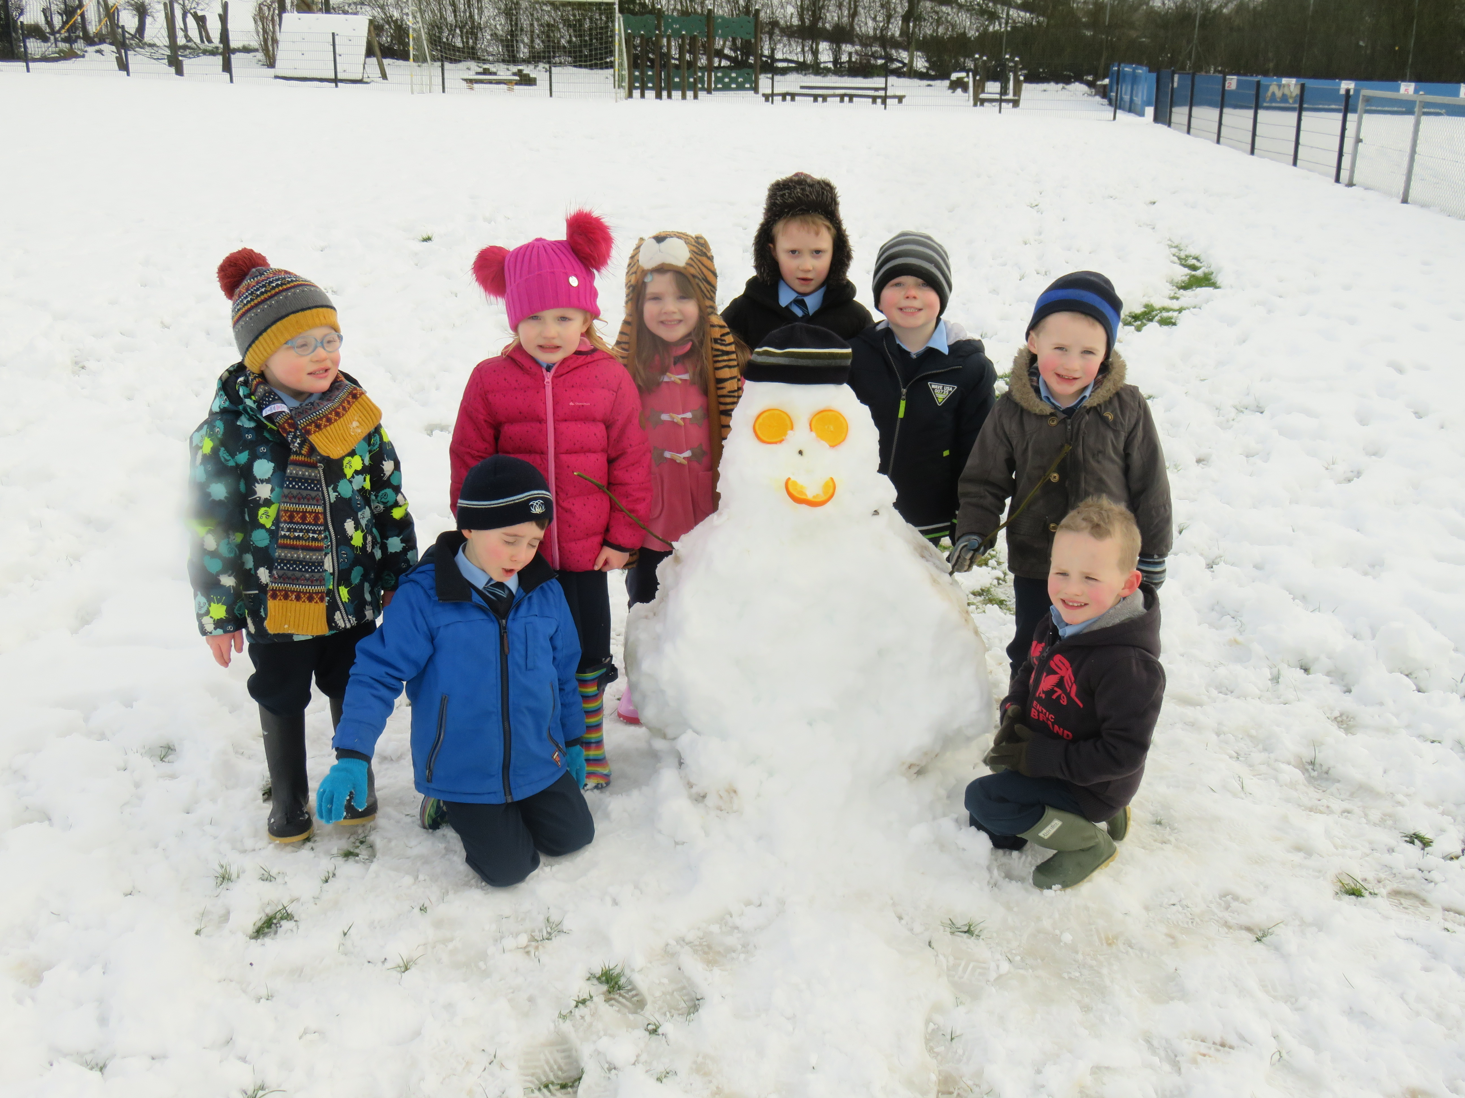
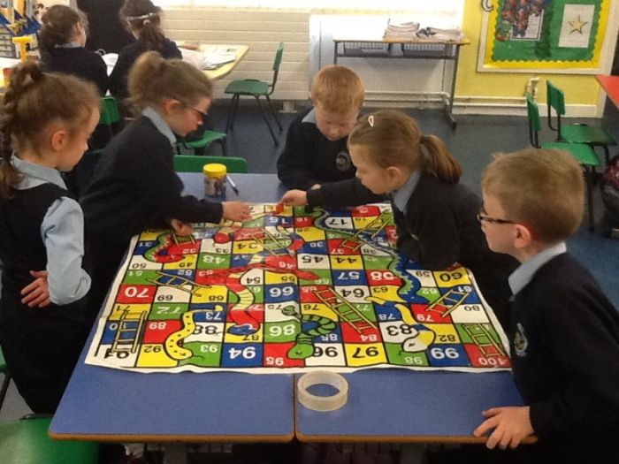
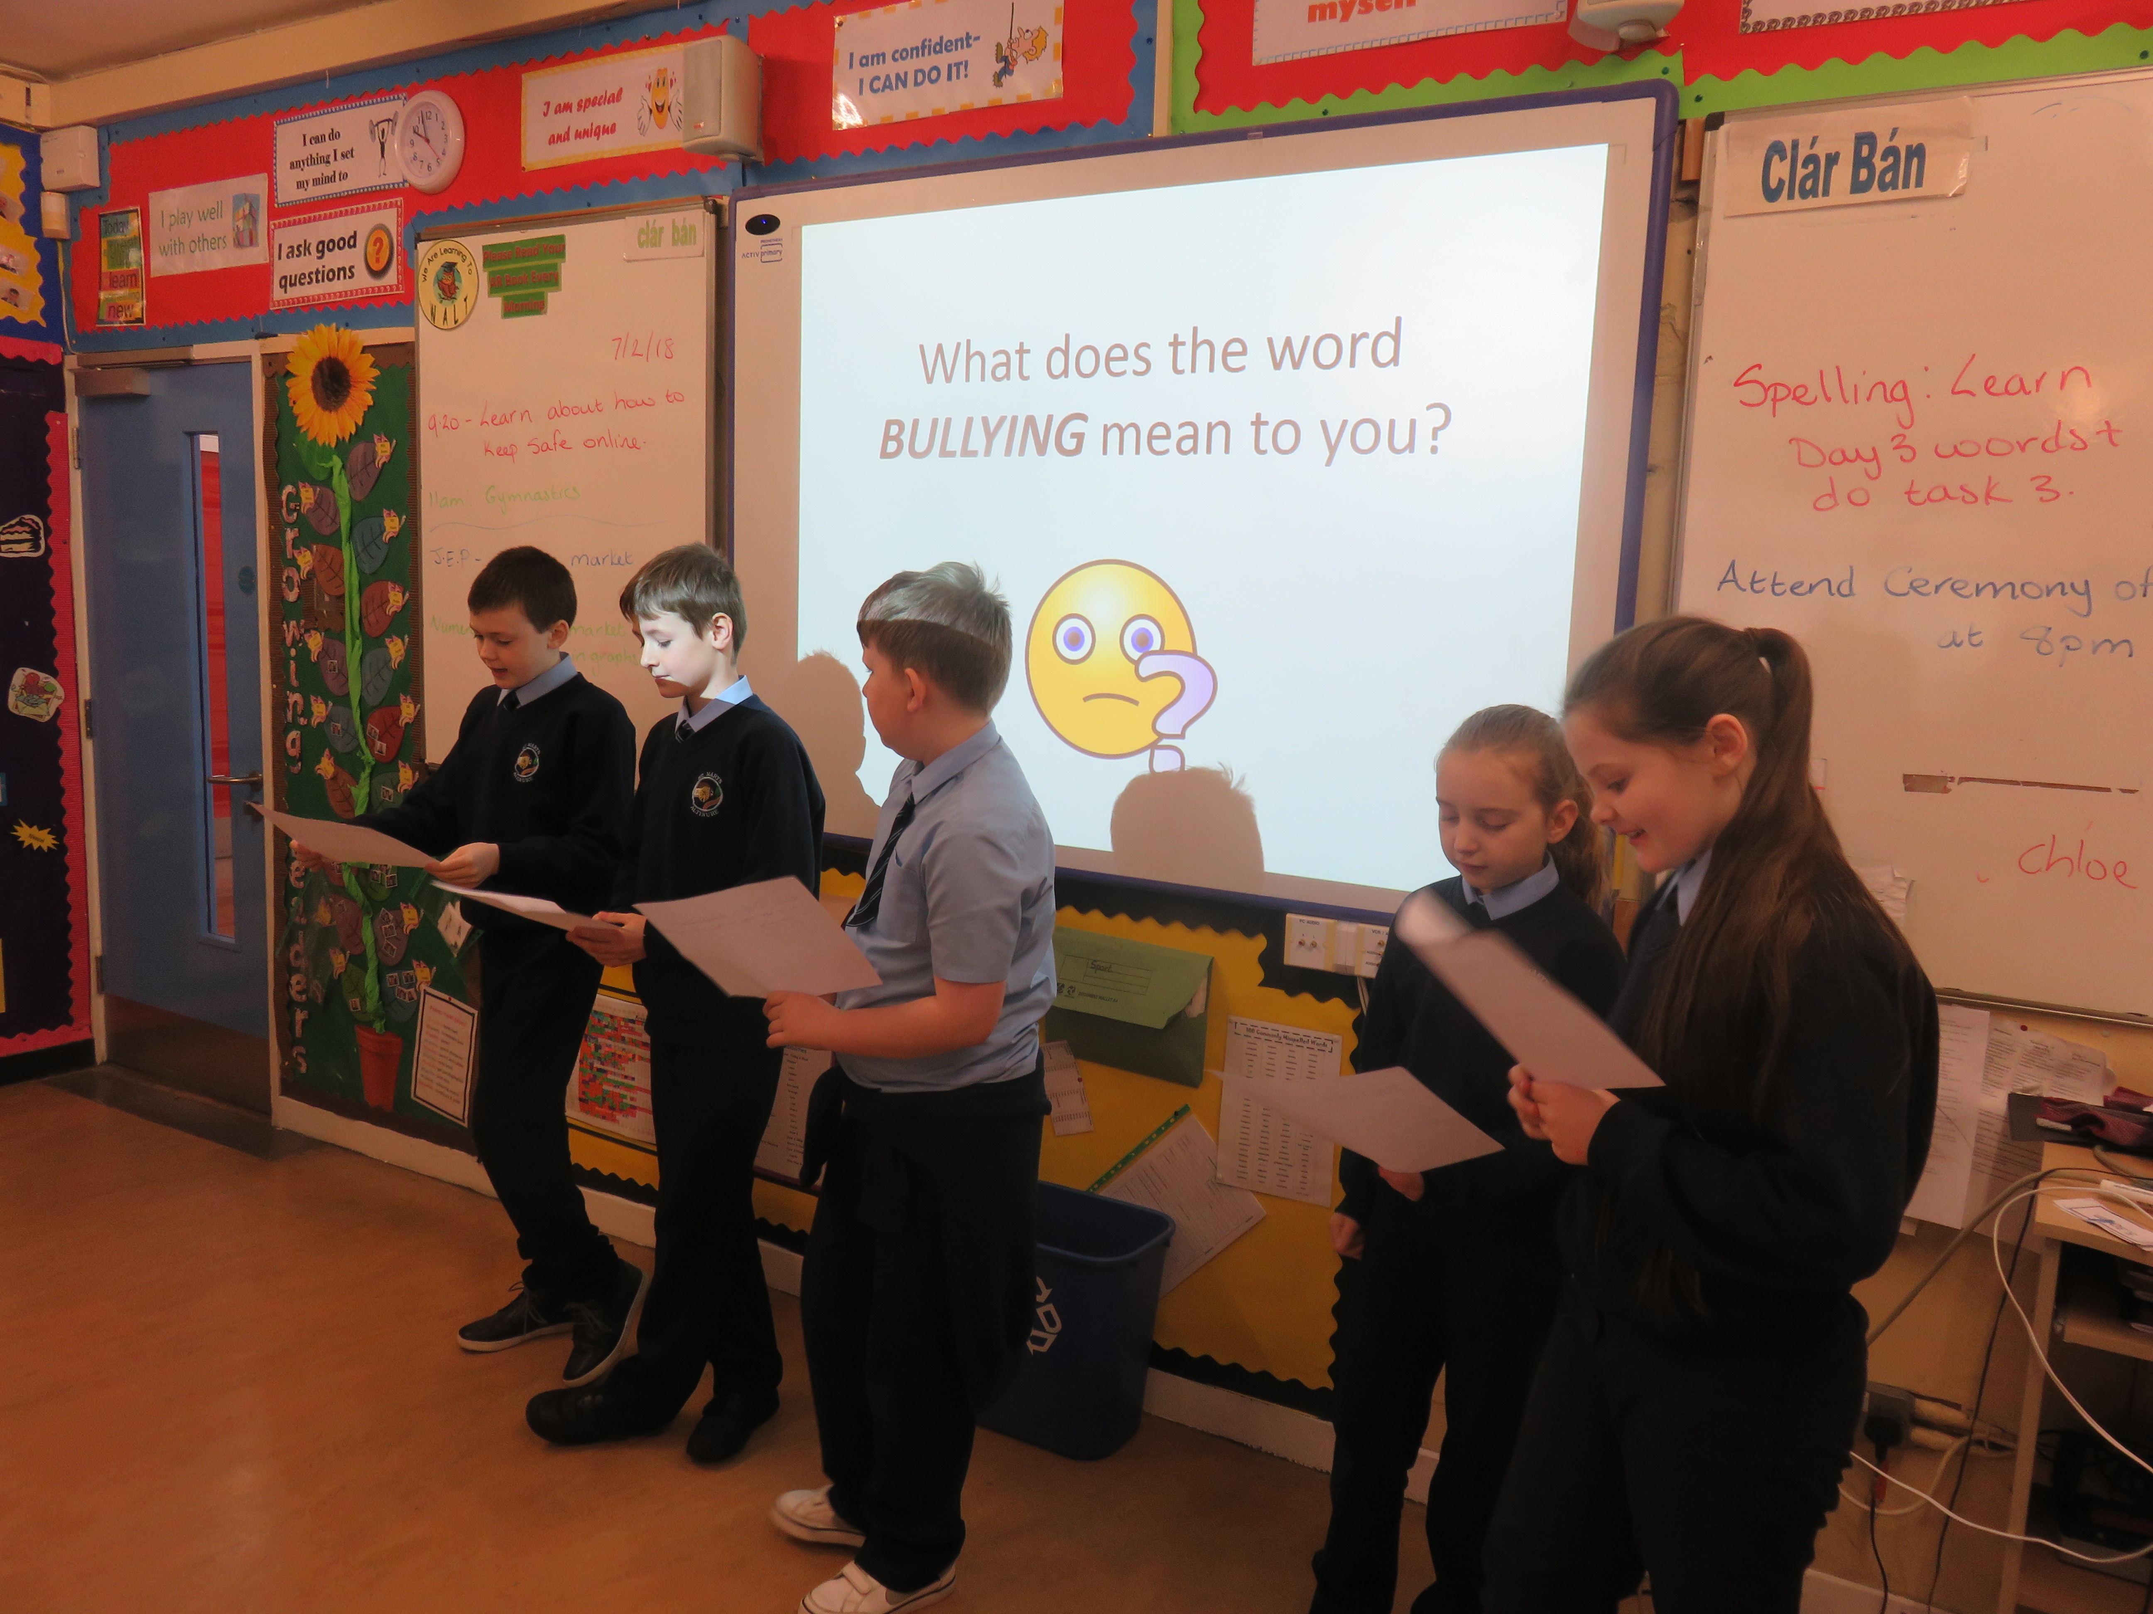

Maths Games in Year 3
Playing in the snow!
Complaints Procedure
An internet safety workshop in Year 7

All complaints with regard to the curriculum or any other matters should be made in the first instance to the Principal.

If the matter is still unresolved then the complaint should be made in writing and sent by recorded delivery, addressed to the Chairman of the Board of Governors. The matter will then be dealt with by the Board of Governors, CCMS or EA as appropriate.

If you remain dissatisfied with the outcome of your complaint, you can refer the matter to the Office of the Northern Ireland Public Services Ombudsman (NIPSO). The Ombudsman provides a free, independent and impartial service for handling complaints about schools in Northern Ireland. You have the right to complain to the Ombudsman if you feel that you have been treated unfairly or have received a poor service from a school and your complaint has not been resolved to your satisfaction.
A complaint should normally be referred to NIPSO within six months of the final response from the School. The school must advise in its concluding letter that the complaint may be referred to the NIPSO if you remain dissatisfied.

From time to time something may arise which gives cause for concern, but may not be classified as a formal complaint. This concern should be made known to the class teacher or Principal as appropriate, either in person, in writing or by telephone. The matter will be dealt with and reported on within 48 hours.

Charging and Remissions Policy

The Board of Governors have adopted the following Charging and Remissions policy:-

A Charging Policy

It is the policy of the Governors to charge for:-

- Board and lodgings on residential visits

- Costs associated with the provision of individual tuition on a musical instrument whether inside or outside school hours unless it is provided as part of the syllabus for an approved public examination or to meet the requirements of Article 11 (1)(b) of the Order.

- Optional extra activities which take place wholly or mainly outside school hours and are additional to the education provided by the school for the purposes of preparing pupils for an approved public examination, or for the purposes of meeting the statutory requirements imposed by Articles (1)(a) and (b) of the 1989 Order. Participation in any such activities is to be on the basis of parental choice and a willingness to meet such charges are made.

B Voluntary Contributions

In cases of activities within school time which the school cannot afford, the school will attempt to subsidize these by asking in advance for voluntary contributions from the parents of those children directly involved. Such requests for contributions will indicate the actual costs to the school and suggest this as a suitable contribution. All the children in the group will take part in the activity, whether their parents have contributed or not. In cases where contributions are such that the school (through the school fund) cannot make up the short fall, the activity will not take place and all contributions already made by the parents for the specific activity will be returned to them.

C Breakage/losses

The Board of Governors reserves the right to seek to recover from parents the whole or part of the cost of breakages and losses incurred as a result of pupils’ behaviour.

Inspection of Documents

A number of documents are available for inspection at the school should parents request this. Parents wishing to inspect any of the following should give written notice to the Principal at least three clear school days in advance of the time they wish to see them. (This does not preclude an informal request to the Principal, who may make the documents immediately available if this is convenient). Copies of the documents may also be made available if a week’s clear notice is given. Payment for copying will be required. The documents available for inspection are:

- The Governors’ statement of the aims of the school.

- Any statutory documents, D.E.N.I. circulars or administrative memoranda sent to the Principal or Governing Body in relation to Part 3 of the 1989 Order.

- Any published ETI reports referring to the school.

- Any management plans or subject schemes which are drawn up with respect to the Curriculum by the Board of Governors.

Conclusion

Now that you have read this School Prospectus, I hope you will have an idea of the rich and varied life your child will have whilst attending St Mary’s Primary School, Altinure. You can rest assured that your child’s well being will be our concern at all times during their years here. I look forward to welcoming you and your child or children to our school.

Yours sincerely,

Mary Redmond

PRINCIPAL

